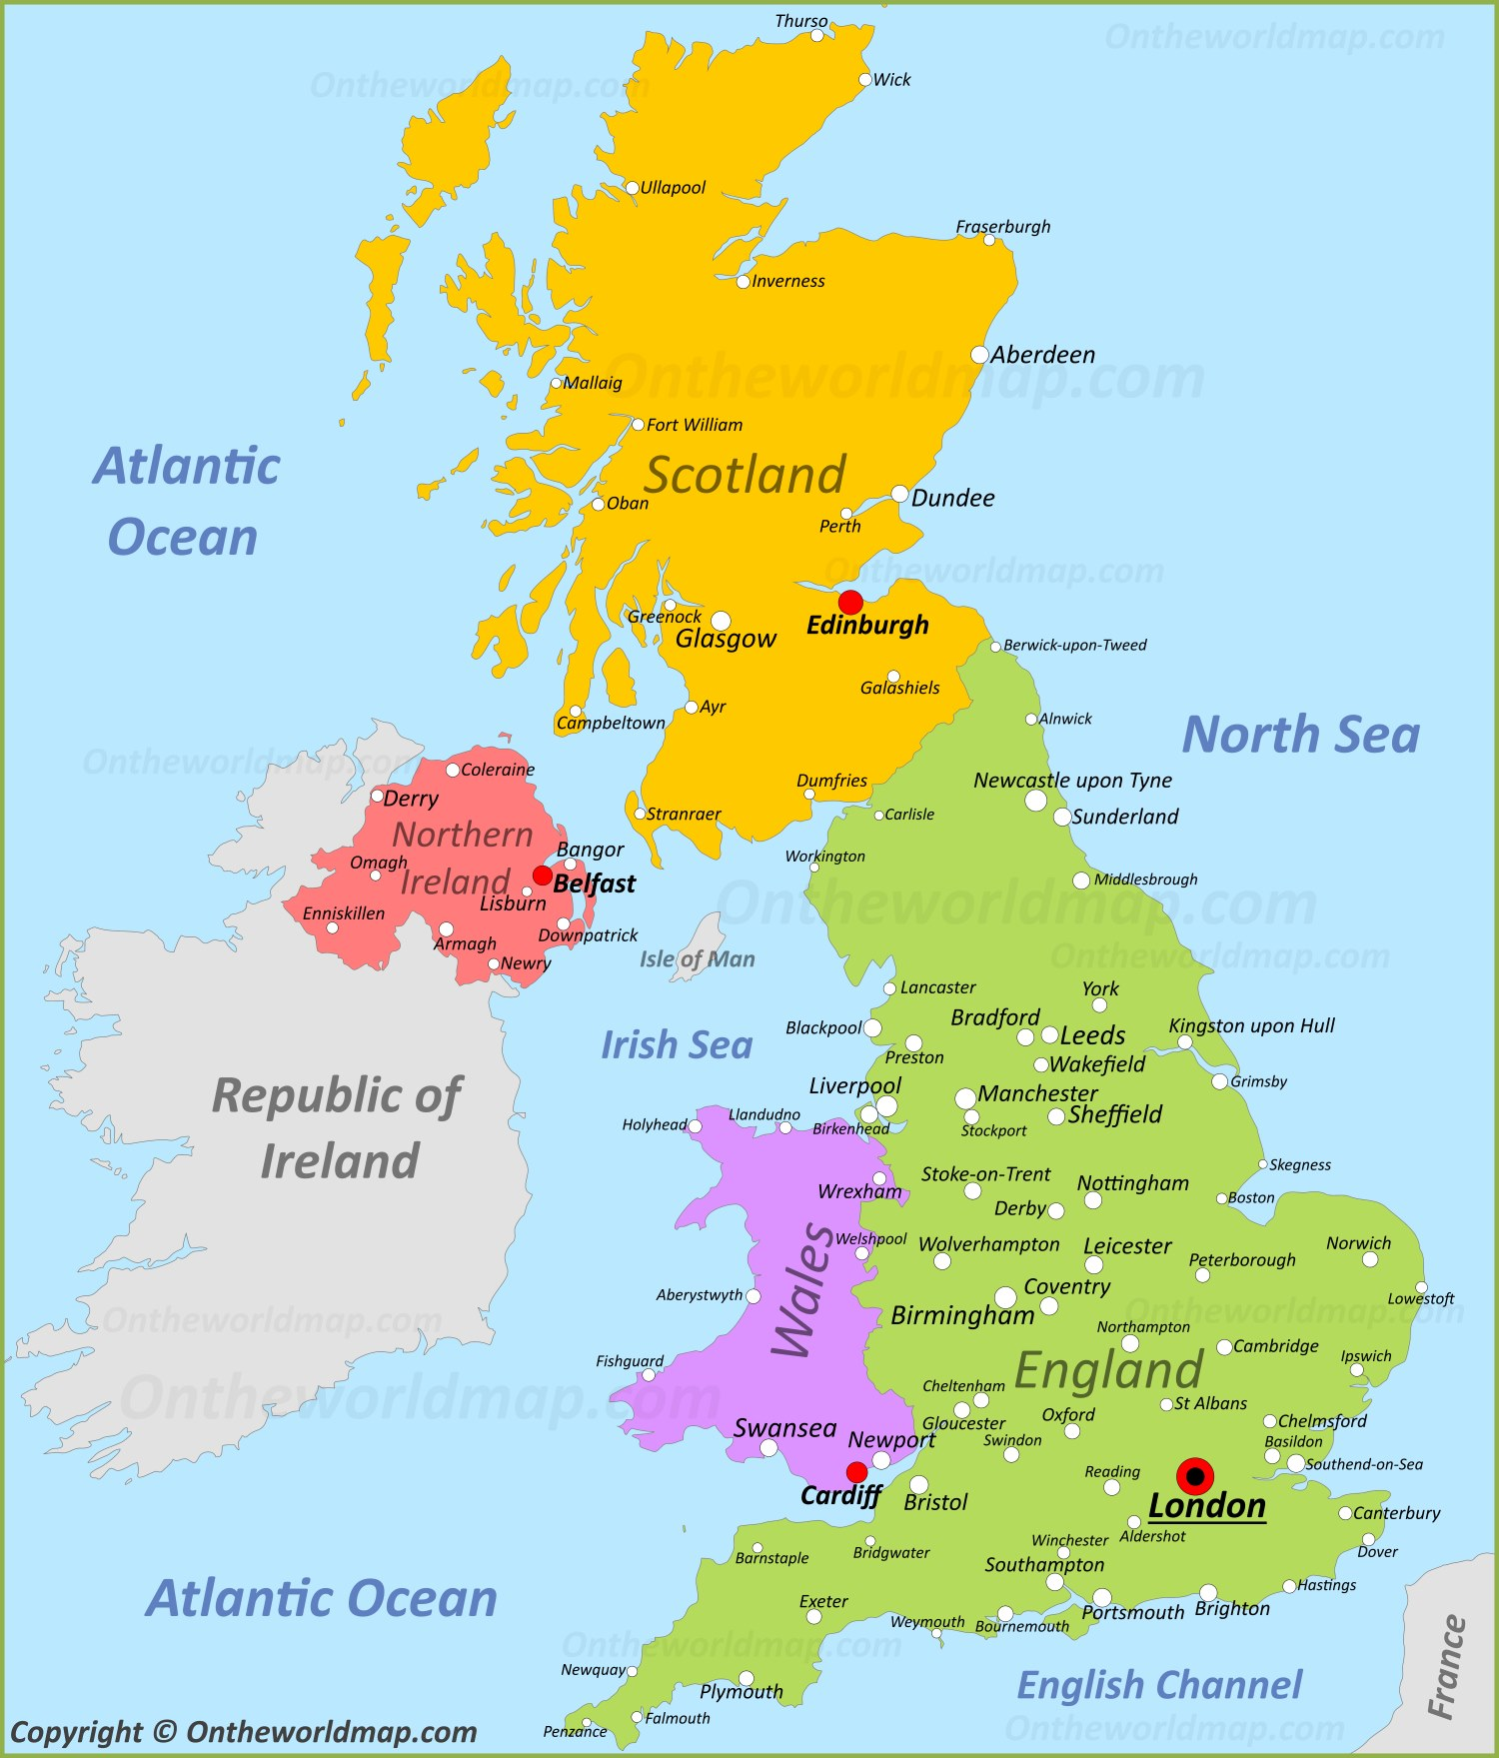
Blackburn College
GRAPHIC DESIGN
UCAS Tariff – 80 points
Arts University Bournemouth
GRAPHIC DESIGN
BTEC Lvl 3 N. Ext. Diploma – DMM
Buckinghamshire New University
GRAPHIC DESIGN
BTEC Lvl 3 N. Ext. Diploma – MMP DMM
DN Colleges Group
GRAPHIC DESIGN
UCAS Tariff – 80 points
Coventry University
GRAPHIC DESIGN
BTEC Lvl 3 National Diploma – DMM
Birmingham City University
GRAPHIC DESIGN
BTEC Lvl 3 National Diploma – DMM
University of Bedfordshire
GRAPHIC DESIGN
BTEC Lvl 3 N. Ext. Diploma – MMP MMM
University for the Creative Arts
DIGITAL MEDIA & MAGAZINE PUBLISHING
IELTS (Academic) 6
University of the Arts London
MAGAZINE JOURNALISM AND PUBLISHING
BTEC Grade

