Graphic Planning

 | Opening Segment | Additional graphic
Describe the visuals:  What will the graphic include visually and why?  You should consider image, colour, font choice/style, positioning etc. | There will be a blue sphere spinning backwards at the bottom of the screen (The red arrow is meant to show where things are meant to transition/move) and graphics of people doing various things as the opening progresses. The characters aren’t realistic to appeal to the secondary target audience, as younger audiences such as students would prefer a cartoonish art style  After the animation, the game show logo/title will appear. The colour will be white as it stands out against the blue background  The colours of the opening will predominantly be different shades of blue, with some hints of white and yellow. This is to match with the colour scheme of the show and will further make the audience associate these colours with the show | 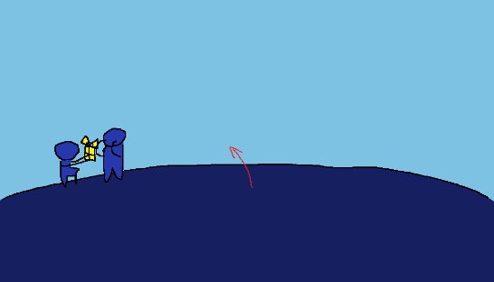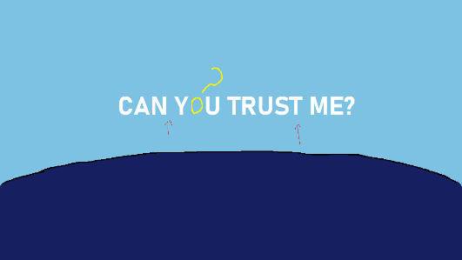
Animation: what will be animated and why? How? | The various poses the characters are doing are meant to symbolise trust.  The first scene is of someone giving a gift to another and the second is of someone thinking about someone else and then recognising them, I chose these two because I wanted to reference some of the answers I got in my questionnaire (when asking what people symbolise with trust, one person talked about giving gifts and someone else said thinking about somebody). The first scene can also link to the third round of having to find a box for the rest of your team  The third scene is meant to be the two characters doing a handshake, this is meant to be before the final round of the show. This is the characters showing mutual trust and respect for each other  The last scene is the two characters in the last round of the show. This quickly shows the audience what the last round will be and shows what can happen in the last round. Despite the characters being seemingly good friends, one was still able to betray another. This displays the shows’ main theme and how, despite the first three rounds featuring trust, distrust and betrayal can still happen at the end of the show  The opening will be slightly animated, the globe will be spinning backwards and the characters will move (bounce) slightly. This is to make them feel more “alive” and not having the audience just look at still images  As the background is looking a bit barren, I might also add clouds there that’ll be more animated as the opening continues. At the 4th scene (split/steal), the clouds could look like a thunderstorm to symbolise the betrayal as well | 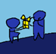 1  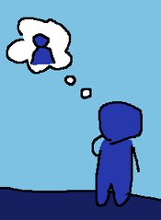 2-1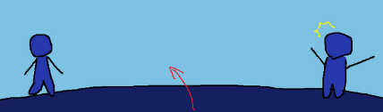 2-2  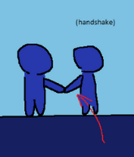 3  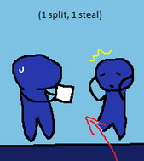 4
Music/SFX requirements: will there be any music or SFX playing during the graphic? If so, what will play and why?  You should locate sources for music and SFX requirements and paste them here. | During the globe slowing down to show each scene, there’ll be a woosh sound effect to emphasise it. I may also use a sound effect for the title appearing around the end. I can use BBC Sound Effects to source this  I will use music that keeps up with the theme of the show. I want it to be slightly dramatic because of the theme but not too much as that’s not the tone of the show  I’ll also try to have a comedic tone in the opening, I might do this by adding extra sound effects to emphasise the characters (gasps for the first scene of giving gifts, a hmm sound for the second scene where the characters thinking about the other person, ect.)
Duration: how long does the graphic need to play for and why? | The opening will be about 10 seconds, which would mean each scene would last for about 2.5 seconds. This is so the audience can properly see the characters posing and will make the title easier to read, the host also says what the show is called at the beginning just in case the audience misses it
Mood board: source and paste ideas for your graphic | 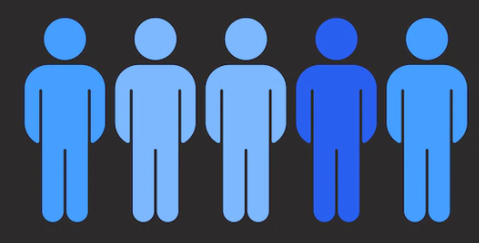  ^ the style and the colours    ^ the style  https://www.freepik.com/ for images of the characters  https://sound-effects.bbcrewind.co.uk/ for sound effects |   ^ the background  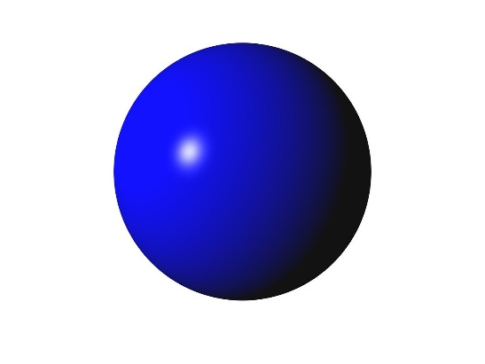  The globe in the bottom will look like a 3d shape, this is to make it more obvious that the globe is spinning

