Masthead
For the masthead (aka the brand logo) I wanted a unique and bold font that would make my magazine stand out against the rest, so I prioritised getting a custom font for this instead of a default one. Having a custom font that no other art magazines use would be the most beneficial as it’d mean I’d be able to “claim” that font and have people think of my magazine when they see the font used elsewhere or another font similar. I was also fine with a simple font that has a lot of charm, this is so I could make one of the dots in “i” a drawing of an eye to tie in the theme (mascot and brand name). Orange means that I’m going to use this one.

vision
[Default] Forte
I like how simple yet easily readable this font is, because of that I’ll be able to customise it easily (make it so the dot in “i” is an actual eye). The font is also a default on InDesign so I wouldn’t need to worry about any issues about embedding my custom fonts. My only concern is that it’s a bit too basic for my liking and doesn’t really stand out.


[Dafont] Danbury Caps
I really like how bold and modern this font is, but I most likely won’t use it for this magazine. It doesn’t really fit with the tone I want for the magazine and would feel more common in an art or sports magazine than an art one.

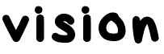
[Dafont] McBungus
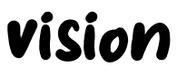
[Dafont] Super Playon
I grouped these two fonts together for the same reason, I like how these two fonts look like handwriting. Having a more handwritten style would reflect the magazine and appeal to the primary target audience more as it makes the magazine seem almost like a sketchbook, which would match well with the drawings that will be in some of the pages. Similarly to Forte I would be able to slightly alter the font as well to include an eye symbol to it.


[Dafont] Murality
I love how bold and eye-catching this font is. It’s also very unique compared to all the other fonts and is easily customisable, it might look a bit wonky though. I really like how the font almost has a more graffiti look to it, this sort of style would appeal to my primary audience. It could work as something to put on the shirt of the mascot if I wanted to do that. I will most likely be using this one, the only issue I have with it is I'm not sure if I’ll be able to use the original colour scheme (black and orange) without it looking a bit tacky
I went on Indesign to test if this font works on it and it does. I already knew my colour palette would include black and orange so I didn’t need to worry about that, but instead on where to place it. I want it to be simple. I liked it as one solid colour but I decided to try as a gradient to see if it works and I really don’t like it. The in-between colours look terrible to me
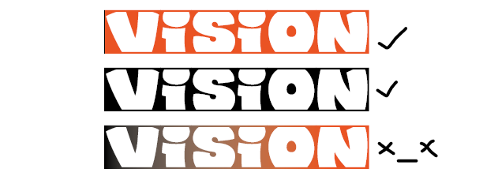
So I decided to go on Photoshop to see if I could do anything else. I typed it out as text, rasterised the layer and then put a clipping mask over it so I’d be able to edit the “background” of the text. I came up with these
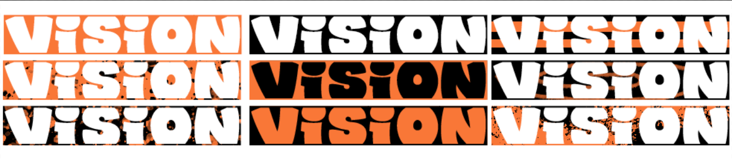
I then narrowed it down a bit to the ones I liked the most, I’m not sure which one I’ll go for yet though I still feel like I like the solid orange or black more. I’ll ask what my focus group thinks later
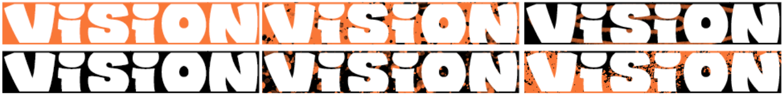


[Dafont] Gogh
This font is very simple but effective, I think the brand name and lowercase style suits the font well. My main concern about it being too simple might also be able to be fixed since this font looks like it’d be easily edited, however I’m still worried it might look too plain for my audience and would be forgettable.

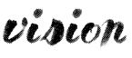
[Dafont] Pale Blue Eyes
I like how this font is very obviously handwritten and made with a brush tool. It further highlights the ”sketchbook” feeling of this magazine as well and is generally pretty while also being readable. The only problem I have with this font is that it feels a bit too fancy for the magazine and feels slightly more high end than the other fonts, which is a shame because I think this could’ve fit.
Headings
For the headings I was much less sure on what I truly wanted for it, only that I wanted it to be fun and bold. I also wanted something that could fit for multiple pages, but I may use different heading fonts for some pages like the generative art one.


[Dafont] Pink Chicken
I like how bold this font is. It‘s also much more fun and different than most default fonts as well, it has a bit of personality and charm to it. It could definitely fit with the magazine and its style. I’ll be using this for a few pages.

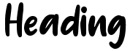
[Dafont] Creamy
I like this font for similar reasons as the previous one, it also somewhat looks like it could be someone‘s handwriting. The font reminds me more of summer and travelling brochures, but I think it could also be a good fit for an art magazine. I might use this one for one or two pages like for the Animation article.

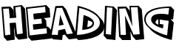
[Dafont] SF Slapstick Comic
I like how the font is bold and very much stands out against the page. Its very clear that if used this would be the header purely because of how different the font is compared to everything else on the page. The only problem I have with it is that it has no lowercase option and while I do like the bold outline effect, I can easily replicate it with most other fonts.

Subheadings
For the subheadings I knew I’d most likely want something italic so that it stands out against the heading and is easily readable as subheadings, but I wasn’t entirely sure on that either.

[Default] Harlow Solid Italic
I like how the font is in italics but is also easily readable. There is also a bit of charm to it as well and it doesn’t look bland against everything else. The font is not too tall so I’m able to put it over the headings text if I wanted to. The good thing about it also is that it sticks to a consistent line and the only thing that deviates from it is the curl of ”g” and any other letter like that for example. The only thing I don’t like about this font is how the ”s” looks, but it’s not a deal breaker for me and I can replace the letter with a different font if needed. I’ll most likely be using this one as it’s the one that fits the best with my magazine.

subheadings, vision, words
[Default on Word] Script MT Bold
This one is a bit more fancier but still feels like it could fit in my magazine. I like how naturally bold the font is as it makes it stand out a bit more. It mostly fits with what I wanted as well, the only problem is that I worry it may be a bit hard to read.

subheadings, vision, words
[Default] Segoe UI (Semibold Italic)
This font is very basic, almost concerningly so, but I still feel like it could fit. I like how it looks as italics and the skinniness of the font works somewhat. It might be a little bit too basic though and I don’t like how the “i” looks much, but as said previously I can change it with a similar looking font.

I decided to test both Headings and Subheadings together as they’ll mostly be paired together. I first tried the two fonts I was planning to pick, Pink Chicken and Harlow Solid Italic. I didn’t like it at all. The two fonts don’t go together at all, so I decided to try out the other picks for subheadings.
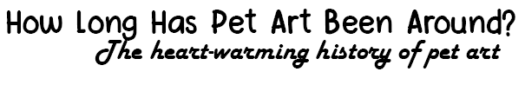

This is Pink Chicken and Script MT Bold. The font isn’t actually on Indesign as a default, so I decided to do a mock up here on Word instead. It was exactly what I thought would happen, the fonts don’t match either and Script MT is way too fancy for my magazine.
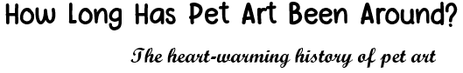

I even tried Segoe UI and while it is the best out of the three, it doesn’t really fit the font. None of the fonts I picked out actually fit this font, which made me wonder if it was a problem with the header font or not. I decided to try out the other header fonts to see if they’d also have this problem.
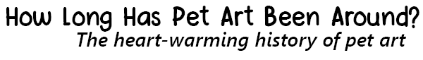

I first started with Creamy & Harlow Solid Italic. The font doesn’t look as bad as Pink Chicken did with it, but I still don’t like it much. I also realise I don’t like how the “r” in this font looks like either.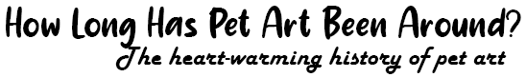

I then tried Script MT Bold, the same problem as before happened so I moved on.
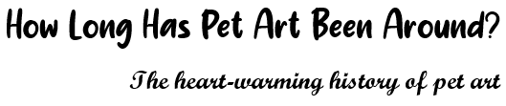

I tried Segoe UI and it doesn’t look too bad. I wanted to try to make the font thicker so it matched with the heading, but that didn’t look right to me either. I might have to use custom fonts as both header and subheading text since they both look strange together.
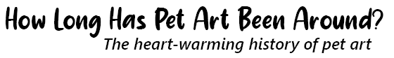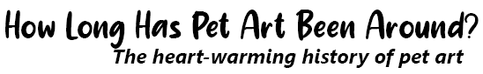

While experimenting I actually found out that this font and Pink Chicken work well together. I’ll most likely use them both together instead of them being separate.
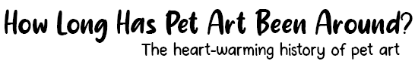
Text
There’s not much to say about these fonts, I only want them to be readable. I’m sticking with default fonts only as I want the main text to be very basic

text, vision, words
[Default] Tahoma
I like how this font is compact while also being slightly taller than the other font chosen. It’s also slightly bold as well. I personally liked how it looked over Arial, I originally chose this one

text, vision, words
[Default] Arial
A very basic font, this is the default for almost everything. I like how simple it is but it being so common might be a drawback for me

text, vision, words
[Default] Arial Rounded MT Bold
I like how this font is rounded as it makes it appear more friendly and childish, which is a good contrast with how other art magazines use basic fonts like Arial or Calibri. I’m not sure I like how bold it is and despite the phrasing this is the only Arial Rounded MT in Indesign. After testing the fonts on Indesign I found that I liked this font much better than the other two though

I decided to test Tahoma on the one mock up page I’ve done and I didn’t like it much at. I think its okay but I prefer how Arial Rounded MT originally looked. I also tried Arial and found that I actually liked it better than Tahoma. After looking at all three of them I decided Arial Rounded was the best fit for my magazine as its going for a younger target audience
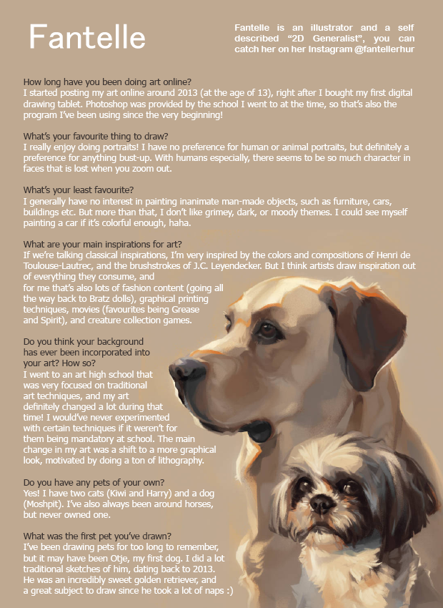 Tahoma

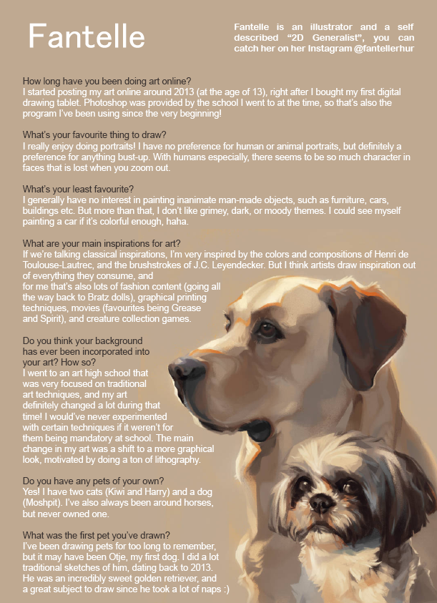 Arial
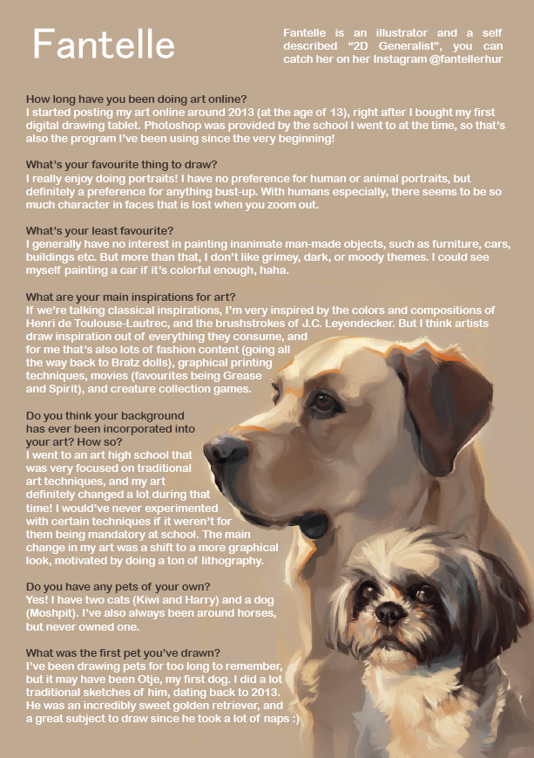 Arial Rounded

