I already knew what I wanted to do for my FMP, as I said in my initial ideas I knew from the beginning of the previous unit. The original idea I had for it at the beginning was to make an art magazine as I really like art and graphic design and knew I’d be passionate for it, but at the time I was also thinking of making it include more than just art. I thought about including musicians, photographers and animators (that’d still count as art but regardless...) into the magazine as well because I also thought those could be interesting to explore as well. The magazine was going to be interactive just like the one from my previous unit. The original name I was going to go with was “I, For Art” but I was considering changing it at the time for obvious reasons, I wasn’t sure if I was going to stick with just art anymore. I still liked the name though, so my idea back then was to make it a “special issue” of the magazine where they celebrated “all artforms”. While I did go back on a few things in the original idea later, the main purpose of the magazine never changed: to interview different artists and see how their background inspires their work
I did some initial research on branding and how many pages interactive magazines tend to have, but the main topic was if any multimedia or creative magazines like the one I was thinking of making even existed. At first I mainly looked at online magazine websites, but those aren’t the same as an actual interactive magazine. I found through my research that there are some brands that do magazines on different things (Communication Arts is a big example, Eye also does this to an extent) but all of these topics were covered in their own separate magazine. There isn’t a single issue that focuses on more than two topics (down below photography, illustration and typography are all separated – these are three topics I wanted to include in my magazine at the time) so I decided to just go back to my original plan and stick with only art, graphic design and also typography. Typography is a new one that I came up with because I’m already super interested in typography and thought it might be able to fit (this is more talked about in Daily Diary 27/03)
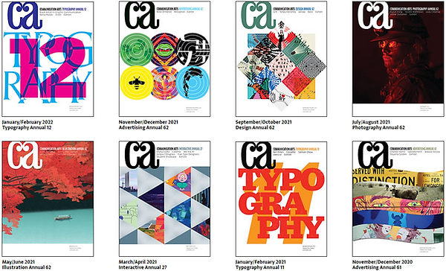
After my initial research I was also thinking about making the magazine printable instead of interactive as I liked the idea of being able to hold a physical copy of the magazine. This meant I scrapped my idea of having a podcast-like video in my magazine (I only mentioned this once in Daily Diary 29/03), although the idea for a video in my magazine somewhat comes back

At the time I thought sourcing artists would be easy and originally planned to get six to eight artists and graphic designers to interview for the magazine, this was because that number was the same amount of artists that were usually interviewed in other art magazines. I also slowly started to get to work sourcing them. I asked two of my friends if they’d want to be in the magazine since I thought having people who did art as a hobby would be a good inclusion and they both said yes. Not to say I wasn’t also messaging professionals, on the 27th I messaged Fantelle about being in the art magazine
My project proposal draft is insane to look at now, I was originally planning to do 30 pages and interview 8 artists and graphic designers. When I worked on my project proposal on the next day I realised that this was ridiculous and changed it. I got that number because I thought I’d do a double page spread for each artist interview and each article (which would be 32 anyway - not including any editorial notes, table of contents, ads or front and back covers - so I also got that wrong), but my teacher suggested having a double page spread consist of one article page and one interview page and that was a much better idea. I was also planning the target audience to be 15-30 year olds at the time but that changed after my pitch feedback
Looking at my current project proposal sheet though, I mostly stuck with what I wrote in it already. As said already the “big feature” of the magazine is still the same, I also went with 15-20 year olds being my main target audience (21-25 year olds as secondary, 10-14 year olds as tertiary) and I interviewed six artists and graphic designers like I said I would. I said that I might have to take a picture of the artists but I didn’t end up doing that, mostly because I’d only be able to do that with two out of the six of them and it’d feel a bit out of place if I only did that with a third of the people interviewed. Another difference is that I said the magazine would be free, but because of the feedback I got from my pitch I reconsidered that and instead it’ll now cost £9 for a physical copy of the issue. The biggest difference would have to be behind the scenes, I said I’d interview a magazine writer but none of the ones I contacted responded back to me. For the final product I actually got two responses from different magazine designers, a few art students in the college (both of them not being planned in the project proposal sheet) and my focus group. I also technically got a few comments from the printers themselves as they couldn’t actually print my magazine at first, but that’s something I’ll leave to talk about later. The schedule I had in the project proposal is actually different than the one I had for my pitch, but the project proposal one is much more close to what actually happened
I also linked the research list I used, which is a good segway into talking about that. The research I did was heavily important to the making of the magazine obviously. I broke my research list over the Easter holiday down into weekly checklists, this is because I work much better that way than structuring to do something daily. The first week of researching was dedicated to working on writing (topics for each article, how other magazines are designed/written and what tone they use). I also put more general points such as getting more people to answer the questionnaire and contacting writers to give me tips, focusing on getting these early meant I was more likely to get responses in time. The second week was focusing more on brand identity, I also put to research interview techniques this week as well so I’d be able to interview the artists quicker. I was meant to do the interview with the magazine writer by this point as well. The third and last week of the Easter holidays I did research on whatever was left: photography techniques, laws & ethics and Photoshop & InDesign
I did a lot of this research because I genuinely didn’t know what I wanted for the project yet (questionnaire focusing on branding and magazine layout, art magazine designs, colour meanings for logo), some of them were to confirm things I had a basic understanding of but wanted to be confident in (interview, photography and InDesign techniques) and others were because I genuinely didn’t know about them (laws & ethics and making effective headlines)
I didn’t follow the research list completely though, I decided to swap some subjects around during those weeks. I also decided I didn’t need to do research into Photoshop because I already knew all the techniques I might use for the magazine, which aside from one thing that didn’t even matter (upscaling resolution to 300dpi, as shown in my production log) was true
I also did a questionnaire, although that was more about the branding of the magazine so it didn’t help me much after that. It did help me with what it was intended to though, I was very unsure about the branding at the time of making that questionnaire. It also helped me with the tone and aesthetic of the magazine as these were questions I asked about, most of the answers said they’d prefer an informal tone (or a mix of both informal and formal) and minimalism (although the votes on that question were very split as well, minimalism only just won with one more vote)
While making the questionnaire I came up with the idea of another title “Point Artview” that was meant to be a play on “Point of View”, I then put that and “I, For Art” together in one of the questions and asked which one people liked best. In the end “I, For Art” won, but there were also many answers saying they liked neither or didn’t understand what either of them really meant. I did this questionnaire before I did research on other art magazines out there so I didn’t understand the codes & conventions of their titles yet. After analysing my questionnaire answers and doing research into other art magazines already, I decided to come up with different magazine titles instead that might fit. The previous question before this was what people would expect from magazine titles as well, so I was able to use that to help me as well. I chose “vision” as I felt it fit with the conventions of other art magazines (simple but bold, noun, one short word, eye themes are quite common in art magazines)
I said where I distributed the questionnaire in my diaries, but I didn’t say that I also used r/SampleSize and even Facebook for this. I couldn’t use any subreddit’s that were dedicated to art, like I did with the game show unit, as the rules on them were very strict. I first found out about r/SampleSize while I was trying to find more places to post my questionnaire in, I posted my questionnaire there multiple times and eventually got a private message about joining a closed Facebook group dedicated to students sharing questionnaires and then doing others in return. This actually helped me a lot, without this I wouldn’t have had gotten enough responses for the questionnaire. Through that Facebook group I found other groups on the site also dedicated to the same thing, so I posted constantly on those groups as well. There were a few groups that were dedicated to survey sites as well such as SurveyCircle and PollPool that I used that helped me gain around 20 extra responses, with all this I was able to get enough responses to actually analyse the questionnaire in time. Something important to mention is that at the time the target audience was planned to be 15-30 year olds and there was quite a range of people answering my questionnaire, they were mainly 15-18 and 19-25 year olds but there was also a sizeable amount of older people answering the questionnaire as well. This may have been one of the reasons why the answers in it were so split
I was also able to ask the focus group two of the questions that were in the questionnaire, they all said very similar answers which proved what I said in the previous sentence. One of the respondents mentioned that they liked seeing the artist’s reasonings and thoughts behind their art, which at the time was very reassuring to hear as that was what I was planning my magazine to be about. There was also another answer that said they liked seeing the art more and preferred less text, which was the opposite of what my magazine was planning out to be, so that was interesting to see as well. Everyone agreed on preferring an informal tone in the magazine, one of the respondents said it’d be a nice change of pace to all the other art magazines that are very formal. The focus group was comprised of my friends who I knew were all into art (some of them even being art students) and the group was comprised of 15-20 year olds so even though I changed the target audience later on, they were still a viable group to use. I used the same group throughout the entire project and asked them with a few things later on as well
After that came my pitch, I was a bit nervous for it but I ended up doing better than how I thought it’d be. Since I didn’t have a printer at home I had to use the ones in the college and my cue cards accidentally came out almost comically large, but it also made them easier to read and I mostly knew what I wanted to say regardless. The feedback I got also helped me a lot. My magazine being free was an issue as it made the magazine feel cheap and made it obvious that this was made by a college student. The main two important things that I was told was that my target audience was way too broad and I’d have to decide on leaning towards one way or the other, I was also told to do research into printing and any local printers around as I wouldn’t be able to use the colleges printers - which was something I didn’t know about prior. I said I could shorten the audience to 15-20 year olds and doing research about printing was extremely important later. They recommended to have two interviews with the artists if I could, one where I got to know them a bit more and another where I held the actual interview. Another thing they said was to give myself two extra weeks for printing and to not have “bubblegum” colours in my magazine as it would make my magazine feel too childish. I’ll be honest and say that I didn’t really stick with the last few points they recommended for me, but it wasn’t intentional in deviating from what they said
Because I was told to do research into printing, I had to do extended research as well. Aside from doing research for everything I’d have to learn about printing (page finishes, binding, gsm, ect.), I also did research into other art magazines target audience and how much art magazines cost in the first place. I also had to try to contact magazine designers, local printers, magazine readers (this is because no writers had responded to me still) and find one more artist to interview. After finding that last artist, I had to do research for whatever their article was going to be about. I also decided to add colourblindness to it to see what colour combinations I should avoid, to make my magazine as accessible as I could, and to do a bit more research on costume design and concept art as I thought I didn’t do enough on it to make an article on it
After this I should’ve been done with research, but I also had to do research during my pre-production stage as well. This list was much shorter: sourcing adverts, how to make a video into a QR code and to embed custom fonts into my PDF (which I quickly realised didn’t need any research done as that was automatically done when you export a PDF…). I also decided to do research on drypoint printmaking as that was the video was about, although that video was an idea I came up with during pre-production and was therefore a bit more hectic to plan around. I also had to look at printing again during the end of production because of a misunderstanding, I was luckily able to fix it before then though
It’s quite difficult to say what research was most effective and what was the least because everything I did and heard from others had affected the project somewhat. I’d say if any research helped me the most it was definitely the research I did about printing and looking at other art magazines helped a lot as well. Without my research into printing I wouldn’t have been able to tell the printers how I wanted the magazine, possibly meaning I wouldn’t have been able to get it printed to begin with. Looking at other art magazines also helped me a lot throughout the project, for example when it came to production I had made a moodboard of other art magazines and what they do
It’s also difficult to say what helped me the least during research because of the problem I mentioned before. I will say at the beginning that my first focus group meeting didn’t really help at all, especially because most of the people who were on it were American which meant we had different time zones. I quickly learned how to plan around it but I didn’t know it’d be such a problem at the start. Later on the focus group helped me more though, especially with the front cover and the mascot design
This is very obvious when looking at my page or even my bibliography, but this is the most research I’ve ever done for a project (I’m pretty sure my first FMP page alone is above anything I’ve ever done for a single unit before) and I mostly covered everything I needed to. At the time doing all of this research was very stressful for me as well, especially considering how I had to work during that research period (my laptops keyboard didn’t work, so I had to look at the sources on my laptop and type what I had learned from it on my phone. I only mentioned it in Daily Diary 02/05 in pre-production but it was very easy to get distracted and working this way was extremely demotivating to me). The Easter holiday didn’t really feel like a break to me due to how much work I put on myself during that time, but I think how I did it was most likely for the better as I was able to source the artists quicker and know a lot what I wanted to do and everything I needed to before my pitch
Despite the ungodly amount of research I did for this project though, I still could’ve done a bit better. I should’ve sourced the adverts from the beginning instead of waiting until the very last moment to do so and I did have to go back and do more research on costume designs & concept art because I didn’t feel like I had anything to say about it, due to how my original research on it focused on period vs contemporary costume design. My research page in general is also a bit of a mess due to how I structured my website, the entire research from Easter is two long text boxes with the diaries being separate text boxes that are in the middle of the longer ones. It’s even hard to explain without it becoming confusing, but it makes this page in particular a nightmare to structure and add things to. There are still times where I have to quickly re-publish the page because the text boxes somehow keep getting smudged together
I think for the most part though I did well with my research, I used multiple sources for every single point I did research for and my commentary clearly shows what I learnt from them as well. I’m not sure if I’ve really “improved” since the previous unit, more that I’ve just done much more research than that unit. I’m very proud with how I can do research, the only thing that bothers me is that I don’t feel my practical skills are as good as it. I can only improve that by using the technology more though
Finally moving onto pre-production, I was able to source the last artist I needed by then and I first started with writing the article drafts. I was told that I did this earlier than I really needed to, a sentiment I now agree with as doing this early made structuring the pages a little difficult
For pre-production I focused on documents for various things, articles, interviews and once again on branding. I also had to communicate with my focus group for a few different things such as mascot and logo design. Showing attention to detail, I had to go back on the documents a few times to make changes or to properly add something like with the equipment list and design brief. I had to use the interview techniques and skills I researched about for the interviews, especially the two that were conducted in real life such as the ones with Lynsey Moore and Alexandra Stan. Listening back to the recordings linked in the artist profiles in the FMP page, I feel like I was better with Lynsey Moore than Alexandra Stan. Despite the research I did warning me not to, I felt that I may have rushed Alexandra’s interview a bit too fast. I understand why though as I actually did have a time limit for that interview as her class would be starting soon
Pre-production is also when I realised that the schedule I set out for myself in my pitch slide and my original project proposal just wasn’t possible, I mentioned this in Daily Diary 05/05. Having only five days to design all twenty of the magazine pages is impossible really, I had to stay in a lot of extra days to finish the magazine in production and I only spent about two days on editing my video after that. During this time I tried to work ahead of schedule by showing the focus group my logo and mascot designs earlier, thus trying to remove the problem of some of them not being able to respond due to time zone differences. I also worked on my mock up fairly quickly as well
I did InDesign experiments after my articles and I understood it quickly, this led me into immediately designing my magazine instead of focusing on mock-ups. This is a mistake I made in the original interactive magazine unit as well at first, I’m not very good at making mock-ups because I immediately want to start designing. This was actually a bad thing as it meant I didn’t have a solid framework on how I wanted my pages to be designed, at the end of the pre-production page I made sketches for page designs I could do to compensate for this but I didn’t end up following most of those either as they didn’t look as good as I thought they would (the animation vs illustration page especially). The only page that looked similar to any of these was the costume design page
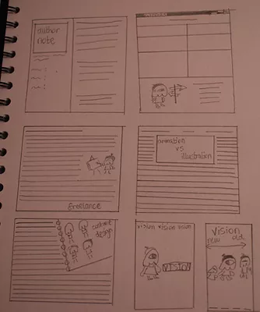
I didn’t really find anything in pre-production enjoyable per say, I was mainly waiting on production for that, but I did get to draw the mascot and have it count as work so I suppose that counts for something. For the negatives though, as I said in Daily Diary 25/04, I don’t find writing articles all that fun. I was able to do it quickly to a standard I was fine enough in to show as a draft, but I’ve never been interested in writing about non-fiction. Despite my focus group all being my friends and all of them being people I know already, there were a few times where I found myself a bit anxious to talk to them at all. This is mainly for personal reasons as I don’t often put myself out there and start conversations, but I ended up getting over it at the end of the day
Production was meant to be fun and it was for the most part, but all of the days really blend in together during these weeks. At the beginning I wasn’t really confident in how I was designing the magazine, but after creating an inspiration board for magazine pages I was able to work much better. The same can be said for the video, although instead of me making an inspiration board that was after watching one or two how-to videos myself in my own time. I even downloaded a bunch of different fonts that fit my brand logo more so I’d have more inspiration, something I briefly mention at the last diary at the end of my pre-production page
During production I really put the Daily in Daily Diary, I worked on the final magazine so much that by the end of it I got sick of seeing it all the time. I got feedback from progress reviews and my focus group throughout the process as well and I tried out and added some things to my magazine from their responses (one of the points in my progress review was that I could make the right page one solid block of colour as a background and I was told by my focus group that it’d be a good idea to stick with two main fonts for the headings & subheadings on the articles)
I also can’t skip to talking about the final product without talking about the end of production as well. I explained this in enough detail in Daily Diary 23/05 so I won’t recap it, but it was extremely stressful for me to go through. On that day I had to go back and look at bleeds all over again just in case I missed something and I felt even more overwhelmed because I already knew everything all of these websites were telling me, so when I realised it was just a simple mistake I felt a bit incompetent. If I work with printing again then the next time I do it I’ll make the pages a colour I won’t be using so I’ll remember to put bleed on all of the pages. I also had to make some readjustments to the PDF for it to be printable (the footer was too close to the edge) so there is a difference between the “final” PDF I sent people for feedback and the actual final PDF I sent to the printers. I’m surprised they were able to print out my magazine so quickly though, it was too late for me to pick it up on that day though so I did it the next day afterwards
I sent the emails to the magazine designers before that day though, so they got the “final” version I made on the 20th. Two out of the three magazine designers said that I had to watch my margins because text (specifically the footer) was way too below the page and would get cut off. They were absolutely right about being careful with my margins and I did have to readjust them because of that, Creamers Printers gave me a specific margin size that was considered the safe zone so I was able to follow that. Because I already had most of their feedback prior to having to change things, I was able to add some things they suggested to change before it got printed (such as the slanted ad, it was slightly changed from my “final” PDF because of the feedback given by one of the magazine designers). Another example is that the two of the magazine designers mentioned that some of the headings in the pages (specifically the editorial notes, pet article, freelancer article & animation vs illustration article) weren’t properly centred, I was able to change this before printing as well and I think it’s better
Looking back on it though I planned to contact video editors for the video I made for my magazine but I never did, as far as I’m concerned no one has really watched it yet. This was a mistake on my part, especially because one of the reasons I didn’t bother with it was because I thought none of them would respond (this was a mindset I was semi-conditioned into during the research part, I contacted a lot of people during that time and to this day I haven’t gotten a response from any them). I also wanted to focus more on getting magazine designers to give feedback since the one I was originally talking to stop responding to me, but I still should’ve tried to get feedback for the video as well. I was able to get three magazine designers to respond to me halfway during production though and I have gotten feedback from all three of them about the “final” PDF now as well
The final product itself is a little surreal to me still, I’m surprised it came out as nice as it did. Some of the mascot art is a little pixelated (especially in the animation vs illustration page) which I was worried about when I noticed the brushes my magazine artist was using, but I don’t think it’s too detrimental. I originally planned to include the mascot in all of the double page spreads and aside from two double page spreads (one being an advert) I did do that. There was art that was made for the pet article page that was meant to go with the QR code, but I decided that it’d be better suited to be at the beginning of the video since there wasn’t much space for both the QR code and the art to be together
I think one of the strengths as well is that the magazine is quite colourful and eye-catching due to the right page usually being a brighter colour than the left. This is something one of the artists I interviewed mentioned while talking about their favourite pages, one of them said their favourite pages were the slanted ads for this exact reason. It’s interesting because I said I would avoid bubblegum colours during the pitch feedback, but with pages such as Abbsterism’s page I don’t think I’ve properly avoided that problem. While talking about that page, one of the criticisms I got from a magazine designer was that the colours used for that page (purple on green) was a little hard to read. Green and grey/blue were a colour combination I was supposed to avoid and I did, but I didn’t think about how green and purple might also quite similar. Personally my favourite page is the generative article one, one of my focus group members also said they liked that page the best. I like being able to reference my other hobbies (HTML and CSS) in my works, even if I’m still a little amateur in actually using them. I also like the Emily Zullo page, but that’s more because of how I was able to incorporate the comic art style with the page
This was a concern I had throughout production, but I feel like the magazine’s design feels a bit childish and that partly is because of the bubblegum colours I was told to stay away from. I don’t think it’s a terrible problem because my target audience are younger people, but I’m still a bit worried my layout would appeal to my tertiary audience (10-14 year olds) more than my primary audience (15-20 year olds)
A smaller thing to mention is that in my pre-production page I mentioned multiple times that I wanted the editorial notes picture to be sunny, but as you can see I didn’t get that. I’m still sort of disappointed that I wasn’t able to because I wasn’t happy with the previous photos I took and the weather wasn’t agreeing me on the day I took the picture I liked the most, but I was able to make a joke about it in the magazine so I hope it isn’t too bad

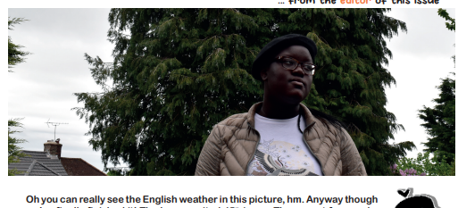
The text came out much bigger than I thought it would and now that I have the physical copy, I should’ve made it smaller. This was something one of the magazine designers I got feedback from mentioned as well, they said that because my target audience is younger people that I didn’t need to make it so big. Two of the magazine designers I got feedback from also said that using a bold font for the main body text was a bad idea as it makes the text harder to read and I personally don’t find it harder to read, but I do think using a slimmer font would’ve been better. The main body font was meant to be a placeholder for the mock up and I just ended up liking it later in production, but I definitely should’ve thought twice about it. Something interesting to note is that during production I asked my focus group what I could do to better unify my magazine and one of them said to make all the headings and subheading fonts the same for all the article pages, but one of the criticisms I got from one of the magazine designers is that I should’ve tried to use more fonts for the headings
As mentioned before with the text, the entire magazine came out a little bigger than what I was expecting and I’m not sure I like how I designed the pages as much as I did during production. I find it quite difficult to talk about the things I like about any work I do so maybe it’s the high expectations for myself, but I still feel like I could’ve done much better with the design and it doesn’t look as professional as I wanted. Although I do think the professionalism I’m envisioning doesn’t really correlate with what my target audience would want aesthetically
On my project proposal, I said one of the reasons I wanted to do a magazine again was because I thought I could improve on the magazine I made previously, especially on the front cover. I think the front cover is better than what the one I made for interactive magazine, but it doesn’t truly feel like a fair comparison either. The cover art I made for this magazine does fit the codes & conventions for an art magazine but it wouldn’t be a good one for a fashion magazine and the same goes vice versa
It’s a little hard to compare it to art magazines (especially the art magazines I used during my research) because most of them are aimed at a much older audience or don’t have much text (Hi-Fructose). I’ll mainly be comparing to Illustoria even though it’s aimed at a younger target audience than what I’m aiming for, since I used some of the pages in that magazine in my inspiration board
The front cover of the magazine is very in line with what other art magazines do, the entire cover is art and the only other text in it is the brand logo and the issue number. The art isn’t too simple (in my pitch I said I wanted it to be really simple but I decided that it would be difficult to distinguish what the magazine could be about if I do that), but it isn’t hard to read either. I think the magazine cover also establishes how this art magazine is different from all the others as its aimed at teenagers, a demographic I haven’t seen any art magazine go for. These are a few examples of how my cover fits with other art magazines, especially with the minimal amount of text. All of the examples I’ve used are also art magazines I’ve done research into
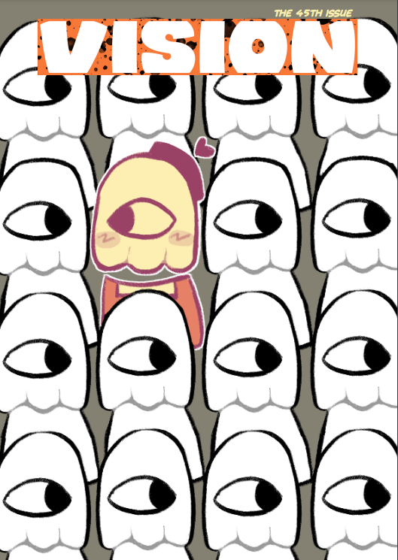 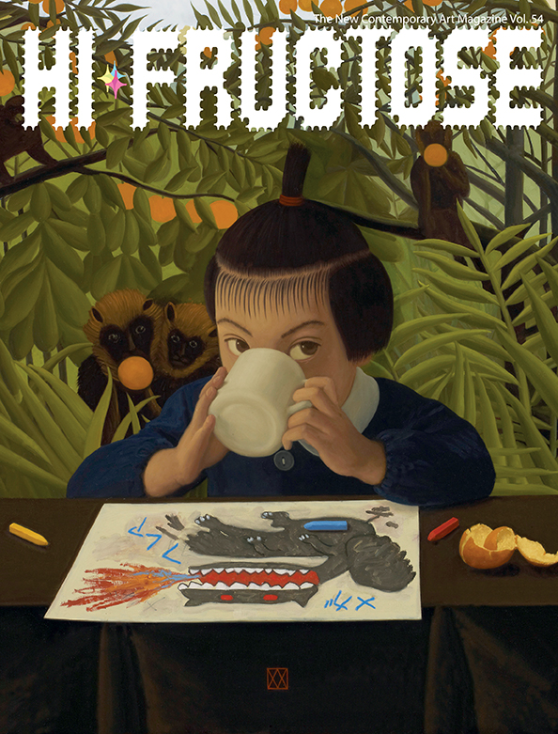
vision (Issue 45), my art magazine | Hi-Fructose (Vol 54), only text being brand title, vol no. & tagline
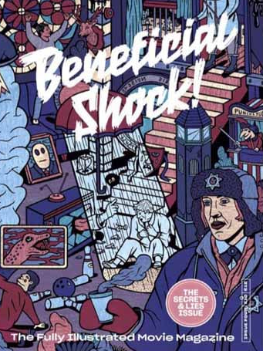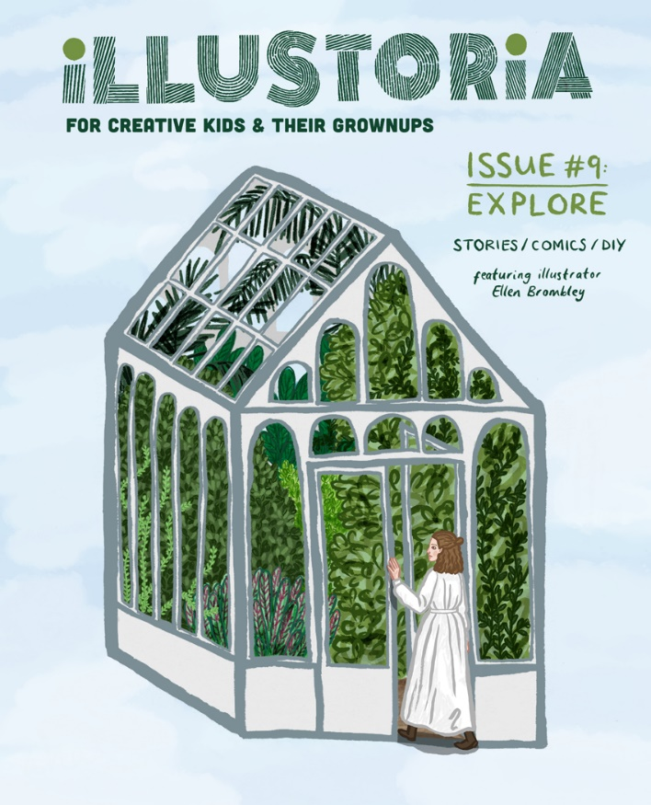
Beneficial Shock! (Issue 5), only text being tagline, issue name & no. | Illustoria (Issue 9), simple cover, tagline, issue name & no.
Pages in art magazines are extremely simple and plain, I tried to make my pages a bit more fun by adding the mascot in majority of the article pages but I still followed with how plain they are. This is an example of how my pages can be simplistic like the ones seen in professional art magazines. I also made sure to have a variety of different page colours
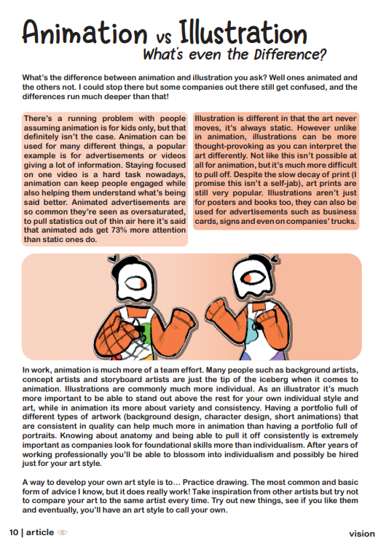 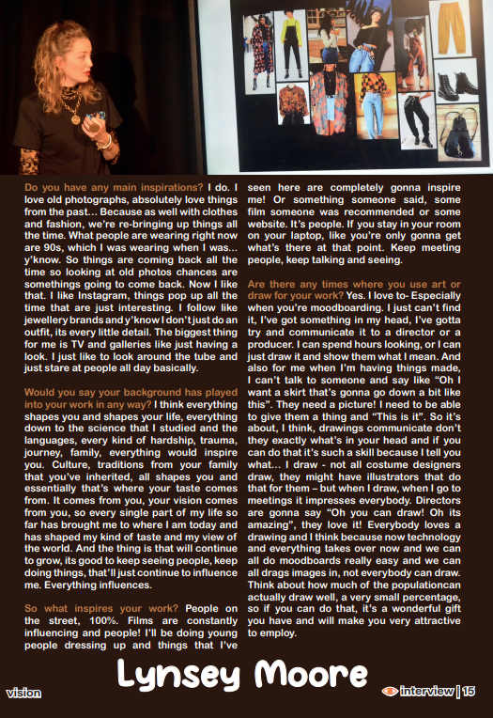
vision (Issue 45), my art magazine. Interview pages are a different colour from the article pages and are always on the right side, this is a house style. The article pages are very simplistic and basic similarly to other art magazine articles
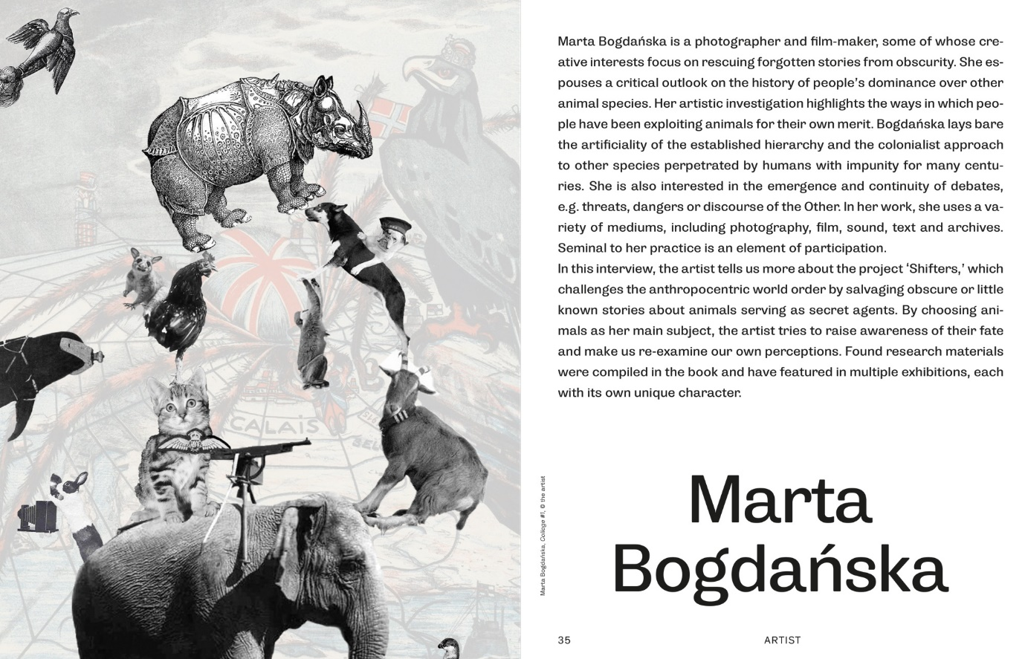
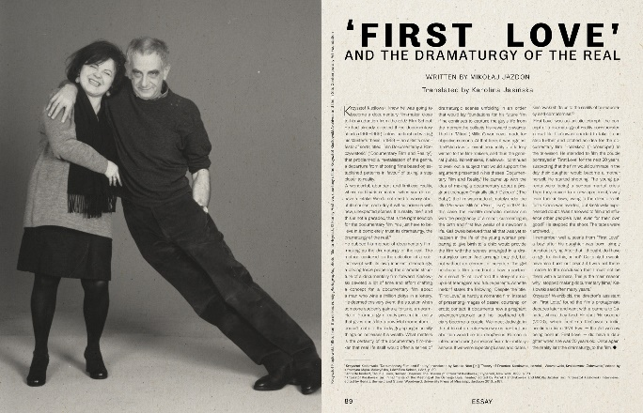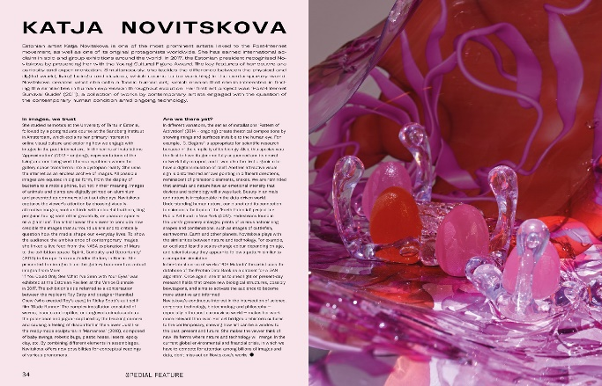
Contemporary Lynx (Issue 17 & 16). This magazine has many pages be a different colour than white like my magazine does, as seen in a few examples here. I took inspiration from the artist pages in this magazine in particular by making all the artist interview pages have the artists names on the bottom of the page instead of the top like what I was originally planning as seen in my mock up.

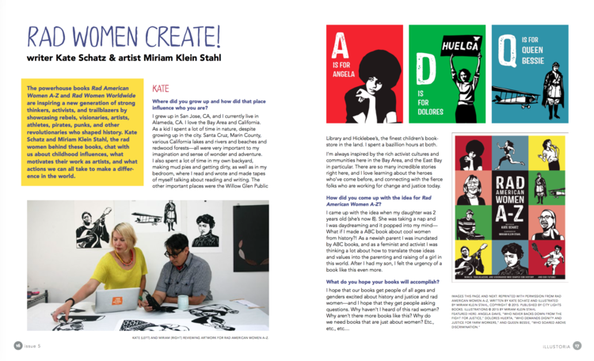
Illustoria (Issue 5). I really liked the bold colours on this page so I took this inspiration for my animation vs illustration page. The colours aren’t as bold as I wanted to make the colours reminiscent of the orange in my logo but not make the text too hard to read
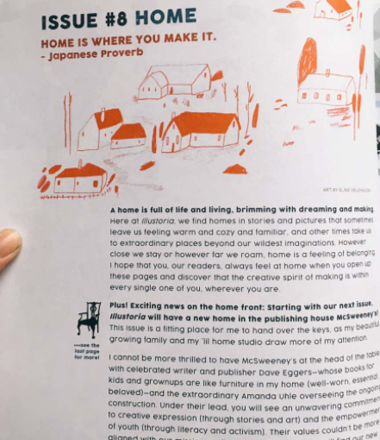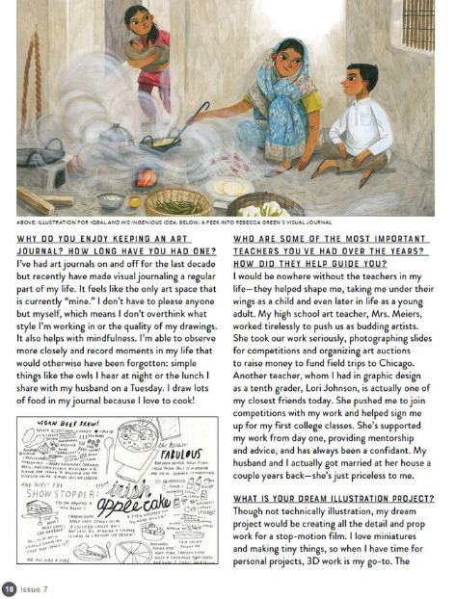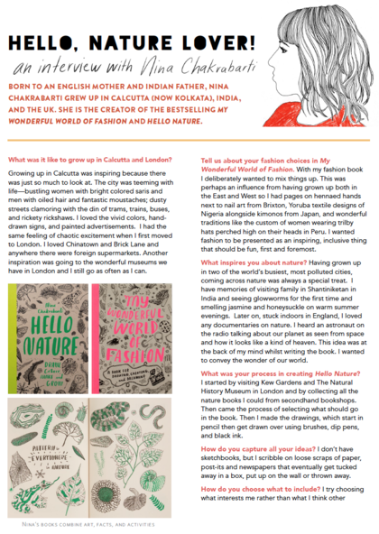
Illustoria (Issue 8, 7 & 3). I unfortunately didn’t have the space to make one page full of the artist’s work and the other the actual interview, so I was able to take the inspiration with the 2nd and 3rd page shown here for my interview pages instead. This is shown best with the Lynsey Moore page above, the top is taken up by a photo like the 2nd page here is with art. Like the 3rd page, the body text is also positioned similarly with it being two columns instead of the usual three I saw used for most art magazines. The questions aren’t a different font from the answers but are an easy and distinguishable colour instead, and they’re not separated with a line break either.
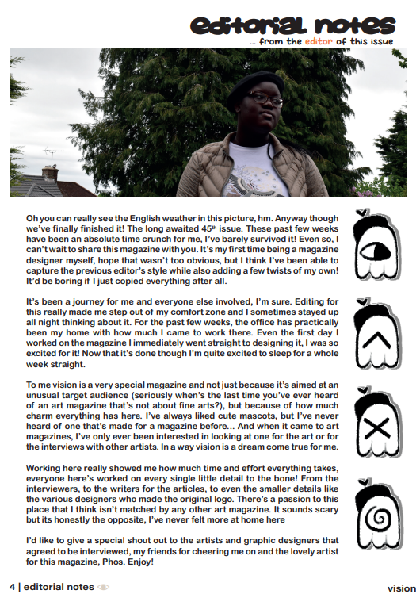
vision (Issue 45), my art magazine. I really liked the first Illustoria page I showed above and was inspired by it as seen by my editorial notes page. The text placement is very similar and I made the image be at the top and close to the text
I even took inspiration from posters while making my art magazine, this is an example
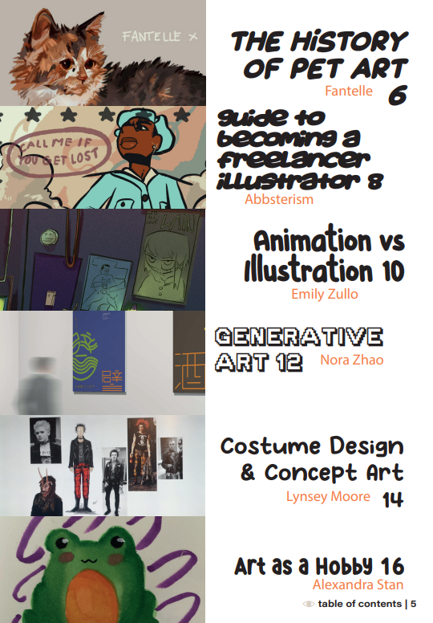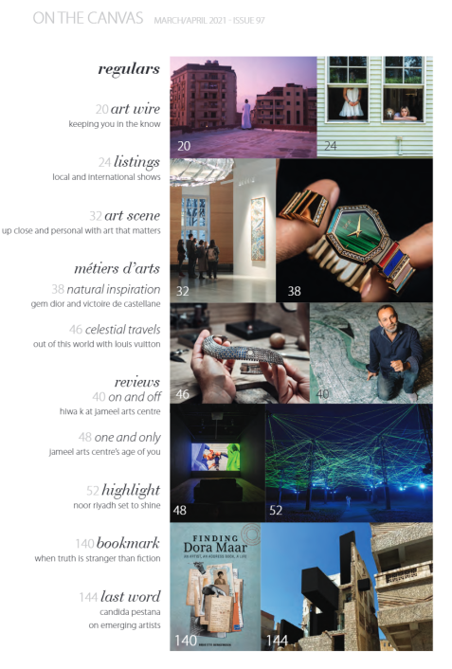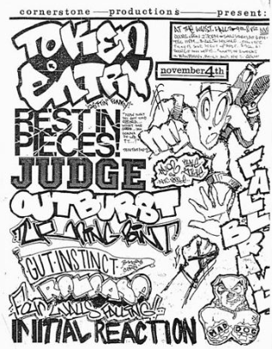
vision (Issue 45), my art magazine. | Canvas (Issue 97) | One of the images in my inspiration board
I really liked how the pictures were part of the table of contents in Canvas. While my teacher was giving me my progress review feedback this is something she mentioned as well, including the art made the page feel much more artsy. For the image on my inspiration board, I really liked how they used different fonts for the text and were close together while still being mostly readable
For if my magazine lives up to professional standards, I think it does. I was inspired by many different art magazines and used their designs in my magazine as I’ve already explained above. The text size being too big and the font used for the headings & subheadings aren’t like the ones I’ve shown above are detractors from that though and I do think my magazine just barely misses the mark of looking as professional as those, although I am once again comparing to fine art magazines as there really aren’t many art magazines dedicated to a younger audience
I still think that for my first time getting something printed and working on a full-fledged magazine like this that I did very well, but I still think I can do much better than this. If I do decide to do printing again for my FMP (which is likely) I think I’ll try to make my product aimed at older people so it meets the professionalism I’m envisioning. I think between the art magazine and making the video that I challenged myself enough, I still think my practical skills are lacking but that’s not really anyone’s fault but my own
I would be lying if I said I found most of this fun, for the past few weeks I constantly thought about how I couldn’t wait for this to be done because I spent so much time on it. Now that I look back on it though I do think if I had properly planned the mock up and got feedback from a magazine designer that didn’t suddenly disappear throughout production that I would’ve had a much better time. This process mostly taught me how long it actually takes to design a magazine (I really wasn’t expecting to spend entire weeks spent here for only twenty pages) and that I am very prone to feeling bad and giving up easily, I can pinpoint multiple times throughout the project where I felt that I should give up on trying to get a higher grade (the last day with the printers was overwhelming because I thought I wouldn’t be able to get it printed on time, even as early as the last day of Easter holiday I was extremely stressed and tired because of how I had to work). I find it really hard to talk about the positives of myself that I displayed throughout this project, persistence is really the only one I can think of because of how at the end of the day I was still able to print two copies of the magazine. Ones right in front of me as I type this. Another thing that really came out throughout this project is that I’m just not really a leader, I’ve never been and I don’t really like being one much. I have my own ideas for things I want to do but this is one of the only times I’ve really acted on one before, so this was definitely a bit of a new experience for me. Starting conversations and constantly contacting other people was a little straining to do at times as well, I find it draining personally
When talking about this year generally though, I think I’ve done really well considering where I came from. Last year I was doing my GCSE’s and I was able to go to Level 3 still, majority of my class came from the previous year and I can still work about as well as they do. I can’t even look at my Music Video unit page because ever since that unit I’ve improved dramatically, especially when it comes to researching
The only problem I really have with myself is that despite being told to, I never really took the equipment out myself much. I don’t really blame myself for this either, it’s kind of hard to fill it in when you don’t know anything on it, but I still think I should’ve at least asked for help about it. Next year I hope to improve my practical skills. I’ve seen some of the units I will most likely be doing next year, so I know I’ll be forced to do just that

