Planning Sheet / Storyboard:
You must create a shot by shot plan for your production. This must cover the entire duration. Remember you must consider what visuals and audio you need. You can demonstrate planning of SFX, music and a range of transitions and techniques in your editing. https://we.tl/t-S4MliO7IiE (https://www.youtube.com/playlist?list=PLDrYtDIGYKrKyjdhXNpojN5soSUgkg_rn)

Shot No | 1 | 2 | 3 | 4 | 5
Time Stamp | 00:00:08  8 seconds | 00:00:15  5 seconds + 2 seconds | 00:00:18  3 seconds | 00:00:21  3 seconds | 00:00:26  5 seconds
Shot Draw the planned shot or present a screen grab of the shot | 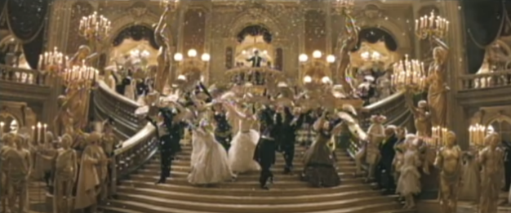 | 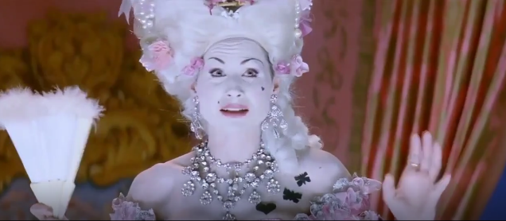 | 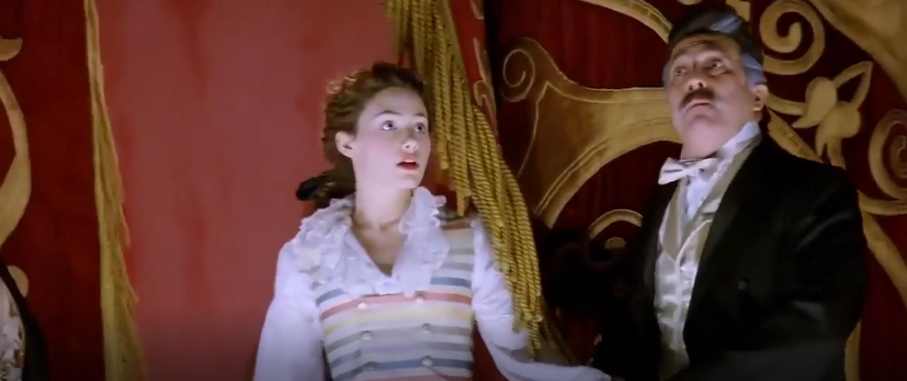 | 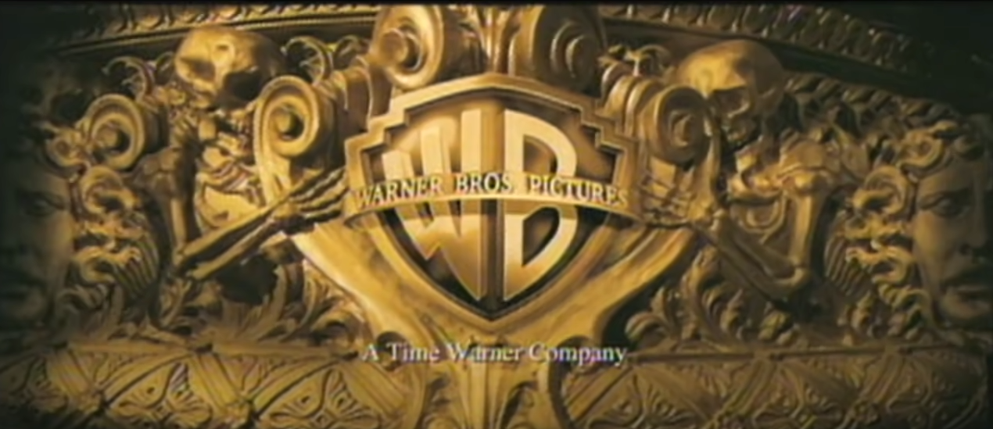 | 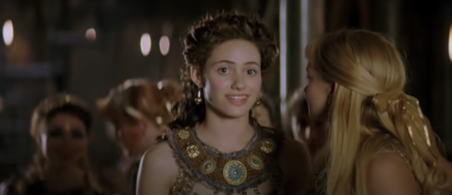
Shot Description Describe what we will see on the screen/which scene or shot from the film will you use? | Montage of the masquerade ball shots and the opera house (at the beginning of the original trailer) | The actress singing and the audience laughing at her. Shot of curtain close | Christine getting picked to be the new star of the show | Production logo | There will be a small montage of different shots of Christine and possibly a scene of her talking
Editing Techniques |  | Fade to black afterwards
Voice/Text |  | Dialogue from the scene | Dialogue from the scene | [txt] Meet Christine..
SFX/Foley Which SFX/Foley will you ad d to promote your genre? |  | Record scratch noise | Foley of studio lights turning on
Music Which music track will you add to promote your genre? | Masquerade song |  |  | Upbeat music | <

Shot No | 6 | 7 | 8 | 9 | 10
Time Stamp You must detail the length of each shot description | 00:00:32  6 seconds | 00:00:37  5 seconds | 00:00:39  2 seconds | 00:00:41  2 seconds | 00:00:48  7 seconds
Shot Draw the planned shot or present a screen grab of the shot | 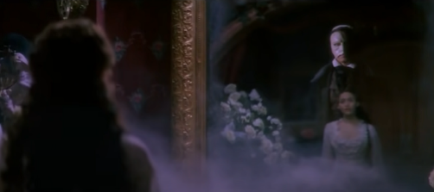 | 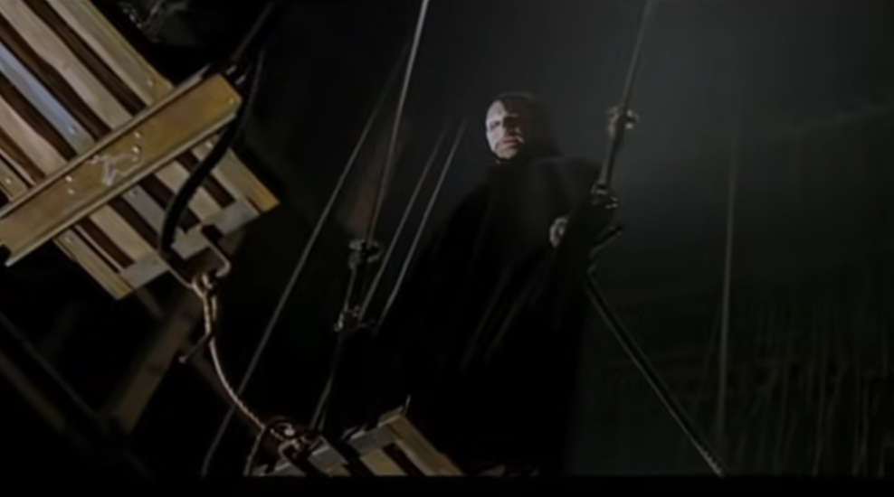 | 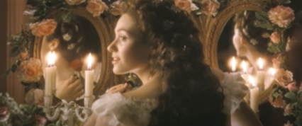 | 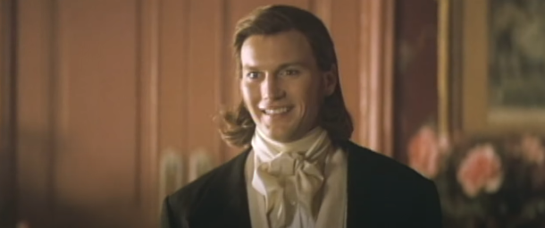 | 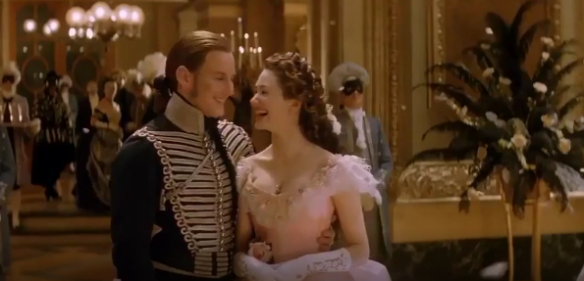
Shot Description Describe what we will see on the screen/which scene or shot from the film will you use? | The mirror scene, introduction to The Phantom | Montage of The Phantom, a lot of the shots being sinister | Christine turning around, maybe a fast cut of the Phantom looking surprised | Raoul smiling at Christine | Montage of Christine and Raoul together, romantic
Editing Techniques  Which post-production techniques will you apply? This may include changing the colour, adding text, speeding a clip up or down etc. |  |  | Linear wipe when Christine speaks to cut to a shot of the Phantom |  | Fade to black afterwards
Voice over/Text You will record your own audio for the trailer… what will you say? For example: ‘This year’s greatest horror…’ | The Phantom saying something along the lines of “Are you ready?” if I can find a clip  [txt] And her doting father… |  | Christine saying Raoul’s name/talking about him and The Phantom exclaiming “What?” | [txt] Who doesn’t like his daughter’s boyfriend! | Christine and Raoul talking(?)
SFX/Foley Which SFX/Foley will you ad d to promote your genre? |  | Lightning crackle
Music Which music track will you add to promote your genre? | Upbeat music | < | < | < | <

Shot No | 11 | 12 | 13 | 14 | 15
Time Stamp You must detail the length of each shot description | 0:00:58  10 seconds | 00:01:02  4 seconds | 00:01:04  4 seconds | 00:01:09  5 seconds | 00:01:12  3 seconds
Shot Draw the planned shot or present a screen grab of the shot | 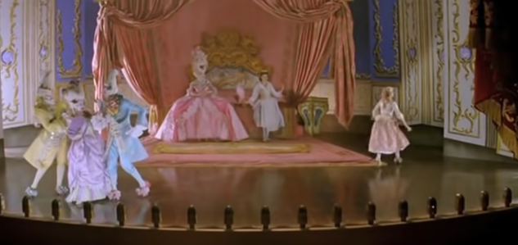 | 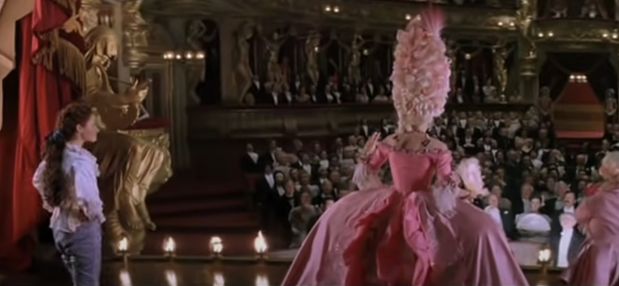 | 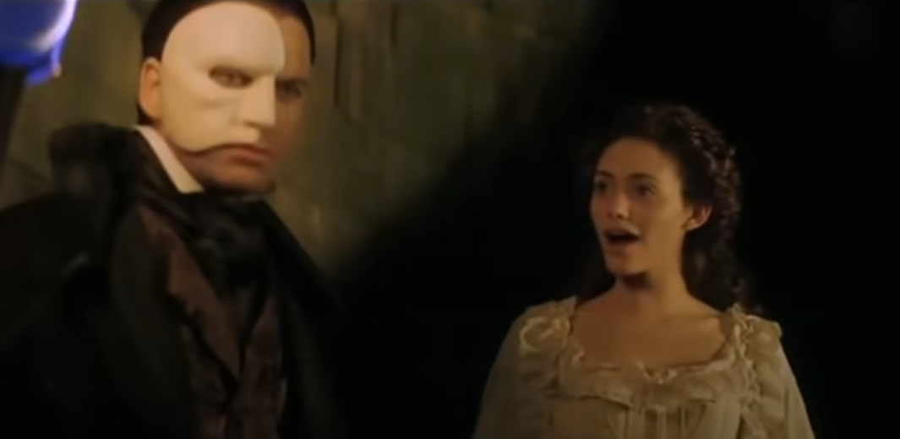 | 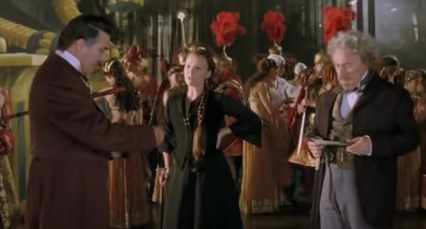 | 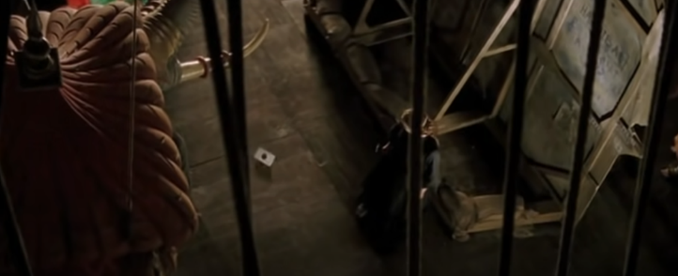
Shot Description Describe what we will see on the screen/which scene or shot from the film will you use? | Montage of a play | Scene of Christine on stage, rehearsing(?) | Scene of The Phantom to let the audience know who sent the letter | Scene of the theatre owners reading the letter The Phantom sent | Scene of one of the theatre owners getting the letter
Editing Techniques

Voice over You will record your own audio for the trailer… what will you say? For example: ‘This year’s greatest horror…’ |  |  | Voice over of the theatre owners reading The Phantom’s letter: “This is my theatre.” | < and laughter from the owners
SFX/Foley Which SFX/Foley will you ad d to promote your genre? |  |  |  | Foley of opening a letter
Music | Upbeat music | < | Music fading out |  | Grand music

Shot No | 16 | 17 | 18 | 19 | 20
Time Stamp You must detail the length of each shot description | 00:01:14  2 seconds | 00:01:07  2 seconds + 2 seconds + 3 seconds | 00:01:15  8 seconds | 00:01:18  3 seconds | 00:01:21  2 seconds
Shot Draw the planned shot or present a screen grab of the shot | 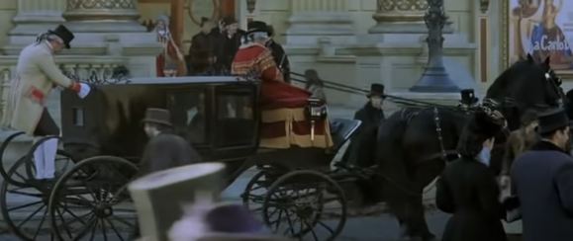 | 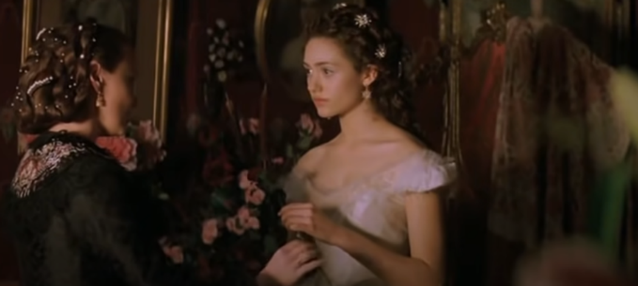 | 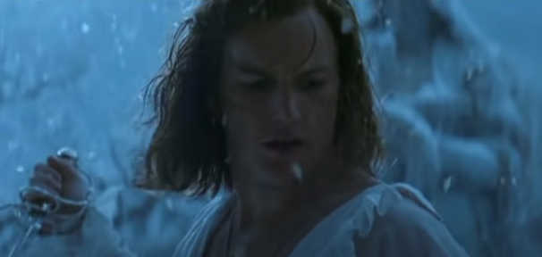 | 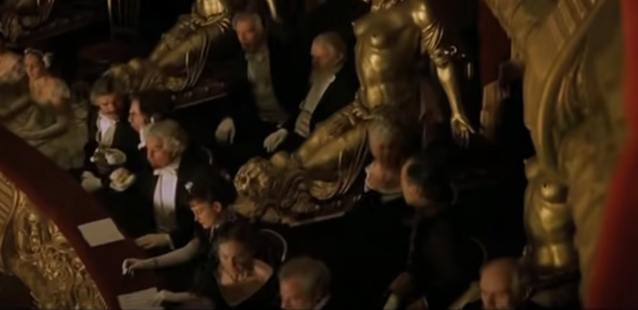 | 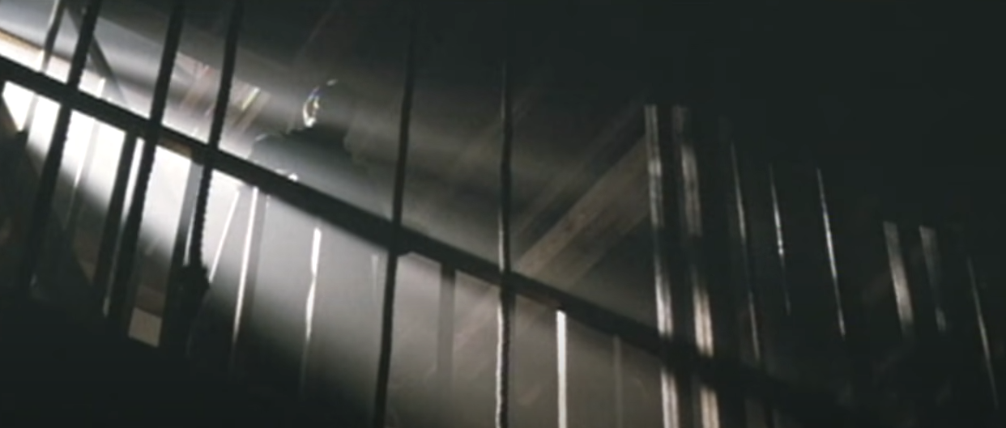
Shot Description Describe what we will see on the screen/which scene or shot from the film will you use? | Shot of the outside of the theatre | Scene of Christine getting ready | Scene of The Phantom and Raoul fighting | Shot of the audience | Shot of The Phantom looking downwards
Editing Techniques |  |  | Fast cut in between Christine getting ready
Voice over You will record your own audio for the trailer… what will you say? For example: ‘This year’s greatest horror…’

SFX/Foley Which SFX/Foley will you ad d to promote your genre? |  |  | Foley of swords
Music Which music track will you add to promote your genre? | Grand music | < | < | < | <

Shot No | 21 | 22 | 23 | 24 | 25
Time Stamp You must detail the length of each shot description | 00:01:29  8 seconds | 00:01:32  3 seconds | 00:01:36  4 seconds | 00:01:41  5 seconds
Shot Draw the planned shot or present a screen grab of the shot | 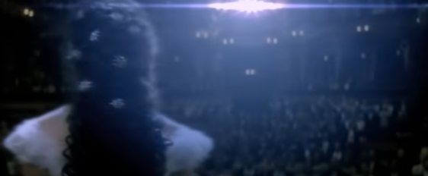 | 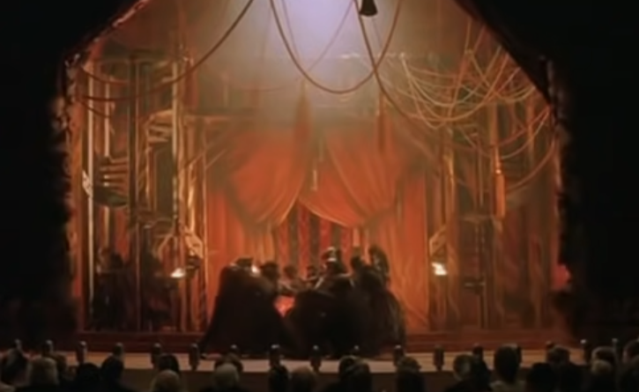 | 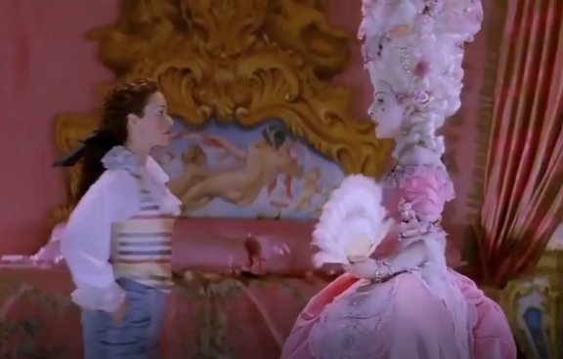
Shot Description Describe what we will see on the screen/which scene or shot from the film will you use? | Shot of Christine practicing and then it transitioning to the theatre | The curtains opening | The actor telling a joke | Title card & credits
Editing Techniques  Which post-production techniques will you apply? This may include changing the colour, adding text, speeding a clip up or down etc. |  | Fade to black afterwards
Voice over | Grand music | Silence after this scene | Dialogue from scene
SFX/Foley Which SFX/Foley will you ad d to promote your genre?
Music Which music track will you add to promote your genre?

Shot No
Time Stamp You must detail the length of each shot description
Shot Draw the planned shot or present a screen grab of the shot
Shot Description Describe what we will see on the screen/which scene or shot from the film will you use?

Editing Techniques
Which post-production techniques will you apply? This may include changing the colour, adding text, speeding a clip up or down etc.

Voice over You will record your own audio for the trailer… what will you say? For example: ‘This year’s greatest horror…’
SFX/Foley Which SFX/Foley will you ad d to promote your genre?
Music Which music track will you add to promote your genre?

https://www.laughingplace.com/w/articles/2019/10/21/analysis-shot-by-shot-with-the-final-trailer-for-star-wars-the-rise-of-skywalker/

https://www.youtube.com/watch?v=N3mL-s-kGw4 – scene for Christine talking abt ruoal

