For this unit we were meant to make a short film based on an auteur of our choosing, the group I’m in chose Wes Anderson. It was between him or our camera operator saying Jordan Peele, we chose Anderson as it was a majority vote and we thought that his use of colour would be fun to work with (mainly through the use of gels and post editing)
Before we chose our auteur, we had to do an essay on if we thought Quentin Tarantino counts as an auteur or not. To do this we did research into what an auteur actually is, watched three of his movies (Reservoir Dogs, Pulp Fiction & Django Unchained), write about Tarantino’s styles in the three films we watched (from reoccurring plots/themes, music, dialogue, shot types, ect.) and then do additional research to inform our opinion on the topic of the essay
Afterwards we did similar research into the auteur we chose, Wes Anderson. I looked into his auteur stylings (he mainly focuses on symmetrical shots, costumes, colours, set design and vintage props in his films). Instead of writing an essay for him, we had to do a short film instead. After finishing the video essay, it was time for us to come up with our ideas for the short film. We decided on a murder mystery in a dinner party since we knew it’d fit in a Wes Anderson film and thought a comedic drama would also work well with it
We wanted to know if Wes Anderson fans would also be interested in this concept, so we made a questionnaire and in total got about 70 responses. The answers from the questionnaire showed us that they would like the film and also gave us a few tips in making it. When we asked what people liked about his films, a few responses said they liked how he used humour in otherwise serious moments which was what our entire film would be about. On another question about what they’d expect from a Wes Anderson film, a response said that they’d expect characters “that are maybe more cartoonish than realistic” with their emotions which most definitely inspired the characters in the film
As the producer, it was my job to find actors and a location for the film. I struggled a bit with both due to the limited time I had and because I wasn’t sure where to find a house at first. I first started with sites dedicated to film locations and found interesting places, but the pricings on most of those were way out of our budget of £40 (as in the cheapest place I found was about £4000 a day). I was recommended to use Airbnb but I didn’t originally due to assuming it was like a hotel site. I then looked at houses that were close to our budget, after that I was told that previous students were able to get a booking for free (they offered to put the house owner in the credits) so I contacted every house nearby to see if anyone would be willing to do it for free
I was able to get a response from someone who would’ve been okay with it but told me we’d have to pay and book to rent out the three days we were filming. I declined and continued searching, I then got a response from another house owner called Michael. After talking for a bit, he ultimately agreed that we would be able to film at his house for all three days. We exchanged phone numbers so we’d be able to talk there instead of on Airbnb
It’s hard to say which research method was the most effective and which was the least since they all played a massive part in helping us make the short film. For me personally the questionnaire didn’t help as much since I’m not writing anything for the film, but for the director it was most likely the most useful research we did. I think every bit of the research I did helped me whether it was for the video essay or the short film, but I’d say the research I did for the video essay helped me the most to understand Wes Anderson’s style. Many of the videos I watched, such as The Wes Anderson Style Explained video, were really informative and helped me to choose a suitable location that was as colourful as the sets he uses for his films
We also got feedback from the pitch we did. As said previously, I really didn’t like the performance of the pitch especially compared to the other groups. Regardless I think the feedback given was important, they said we had to find our target audience so we could cater the comedy of the film to them and to decide on a budget which we eventually did. Aside from that, the only extra research I did was for increasing a specific part of an audio in Premiere Pro while I was editing
Back to my role as the producer, a lot of what I did was socialising and research (to find actors and locations). I’m confident enough in my research skills but the main issue with locations was finding someone who was willing to let us film at their house for three days for free. I recognised at the time that it was a lot to ask. It took a few days but I was able to find someone who did
When the location was sourced I realised I didn’t give myself much time to find actors. I had a few ideas like contacting colleges with performance arts courses and using many websites dedicated to casting actors, but in the end I was only able to get two. I was aiming to get a full cast since its only five people and I think if I did it much earlier I might’ve been able to. On the second filming day I got an email from one of the performing arts groups I emailed (Next Generation Youth Theatre) and they were excited about the opportunity but unfortunately replied too late. I think for that, my time management could’ve been a bit better. I was very focused on finding a location, so much so that it cut time for me to find any actors
For the actors we did find, I kept in contact with them over the days before filming about the script, costumes and where we’ll be filming. We agreed that they wouldn’t be paid but would have a free lunch on the three days we were filming instead
If I couldn’t find a location (which at the time was seeming likely), the production team agreed that we’d use the director’s house to film. The contingency plan for the actors was to have all of us be the actors, but looking back on that now I realise we wouldn’t have had enough actors still. Even with the two actors I found, the sound operator, director and I had to a role in the film
On the first day of filming there were a lot of issues due to us arriving at the location an hour later than I said. I didn’t know how long we’d have to stay in class so I said the call time was 10:15, in class I later texted to the actors that I’d have to move it to 10:30. We had to walk to the location and I heavily underestimated how difficult it’d be to carry the lighting equipment. In the end we arrived on set at 11:20 and had to set up for the first scene, which also took a while. I understand how I made the mistake and honestly don’t think this could’ve been avoided since if I did know beforehand how long we’d stay in the college, I’d have said the call time would be 11:00. Moving forward if I’m ever doing this again, I’m setting the call time on the first day at 11:30. On the next two days we decided that we’d take an Uber to the location instead of having to carry the heavy lighting equipment all the way there
Filming was more enjoyable than I thought it would be due to the actors and crew on set, there seemed to be a fun atmosphere between all of us. We didn’t have to do too many retakes above four on set since we’d usually be happy by the third or fourth take. I didn’t enjoy acting much for the film, but I appreciated how I had the least screen time and lines
On the third day the weather was very cloudy, this made all the shots we did on that day noticeably darker. I didn’t realise this until we were already back at the college checking footage and I wish I realised that the weather would’ve affected the brightness sooner since I knew what the weather would be like. The camera operator on that day didn’t show up either due to a headache from all the lights we were using, so we weren’t able to do a shot how the director wanted (she wanted a camera pan in the last scene of the characters on the couch and Mort, but no one would’ve been on camera to do it). As a compromise we decided to do the scene on two takes instead of one
Next week after filming, we found out that the actors sent a complaint email to our teacher about the production team’s unprofessionalism. We were all shocked to hear this since in the email the actors said they were tired of filming ever since the first day, and obviously from my production logs and diaries on those days I didn’t feel that. As compensation we all sent an apology email and decided to pay them £10 each
When it came to editing, it was also difficult since the main problem with that was making the third day of production’s scenes fit with the other two days. I wasn’t able to completely solve the issue but I think I did a good job using Brightness & Contrast, Color Correction and Lumetri Color on Premiere Pro to alleviate it. I usually find editing to be my least favourite part of projects like these due to the amount of time we get on it, but I think it was more enjoyable than usual due to the colours Wes Anderson uses
I’d say Wes Anderson’s influence was certainly shown throughout the film, but I’m not sure I’d completely say it was in his style. I didn’t know anything about the auteur previously, but through the research I had to do I felt confident about being able to emulate his style. I think my biggest issue with editing was the green lighting since it was so strong, I couldn’t get rid of it so I decided I’d have to work with it. I don’t think green and orange go very well but I think it’s better than what the footage originally was. It really saddens me since I think the natural lighting of the house would’ve been better and for the third day we could’ve just turned the lights in the house on
I’ll be honest that after we heard the complaint letter that all of my enthusiasm and pride for the project was more or less destroyed, but I think I can say I’m proud of the editing I did on it at least. I made sure to use the same font in the title that Moonrise Kingdom did, and I also used footage of The Grand Budapest Hotel to measure the ratio of where to put the black bars in the final edit. When the team were originally talking about the concept for our short film, we made a lot of comparisons to The Grand Budapest Hotel. The sound operator (the person who came up with the basic premise) said he was inspired by that film so I tried to make our short film look similar. I think with use of Brightness & Contrast and Lumetri Color, I was able to get that effect
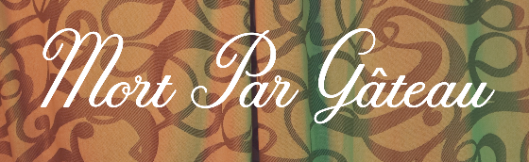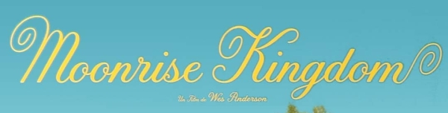
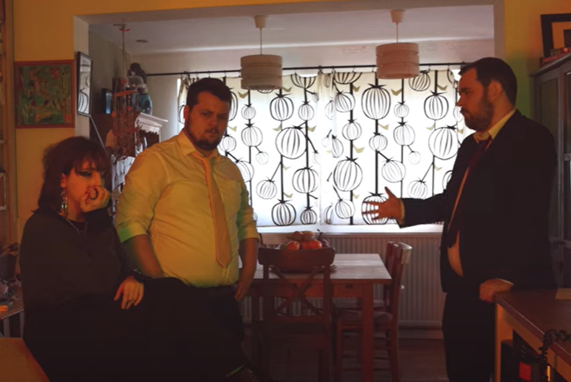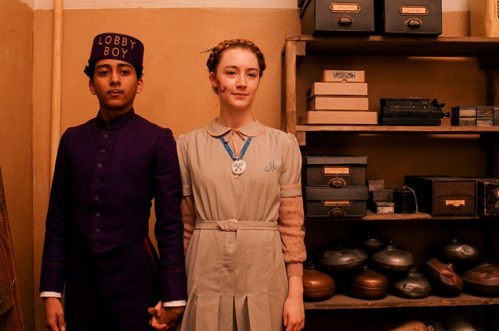
I mainly learnt about editing for this project, especially about colour. I think overall I am happy with how the final film turned out, I didn’t have a clear vision of how the film would look back when we were having production meetings but it was something similar to the final edit – especially the lighting. In the production meetings we mentioned having a specific colour for each character and I think it turned out well, especially during the interrogation scenes. I think a way we could’ve improved the colour though was by making a colour palette for the film
I’m saddened that the actors disliked their time spent filming, but at the end of the day I did think they did a good job acting. I’m also overall disappointed with myself for this project. I already knew socialising was a big problem I had and I thought ever since last year’s Radio Production unit I was getting better at it, but its clear I still have a lot of problems in that regard

