
Location Sheet

Production Name: | Mort Par Gâteau
Group Members: | Jaxmine, Eden, Malachi, Matt
Date of Recce: | 06/10/22
Date of Production: | 11/10/22

Location Name: | House | Name of Contact: | Michael
Location Address: | 63 Wardown Crescent  LU2 7JT | Name of Contact: | Michael
Location Address: | 63 Wardown Crescent  LU2 7JT | Contact Telephone: | 07711 303573
Location Address: | 63 Wardown Crescent  LU2 7JT | Contact Email: | mike@stampede.co.uk

Areas Required: |  |  | Scenes/Shots being captured at this location:
Dining Hall |  |  | Scene 1 – Shots 1, 2, 3 & 4
Kitchen |  |  | Scene 2 – Shots 1, 2, 3, 4 & 5  Scene 4 – Shots 1, 2, 3 & 4  Scene 6 – Shots 1, 2, 3 & 4
Door |  |  | Scene 3 – Shot 1
Office |  |  | Scene 5 – Shots 1, 2, 3
Nearest Medical Support: |  | Luton & Dunstable University Hospital  NHS Foundation Trust, The L&D Hospital, Lewsey Rd, Luton LU4 0DZ  Basic first aid at location
Safety Concerns: |  | Spaces may be cramped due to filming in a house, while filming we’ll make sure there’s a space between the equipment and people on set
Police Requirement: |  | N/A
Security Issues: |  | Will need a key to get in, can also knock on the door if someone’s inside. Shouldn’t be an issue as house owner expects us to be there
Private/Public Use: |  | Private location
Staging Area: |  | An unused room nearby every room we’re filming in
Power Supply: |  | Since we’re filming in a house there should be enough main plug sockets. There are battery packs for cameras
Parking Access: |  | Wenlock Street  Wenlock St, Luton LU2 0NN  Up to 1 hour - £1  Up to 2 hours - £1.50  Up to 4 hours - £2  All day - £5.50  Open Monday-Sunday 5am-10pm  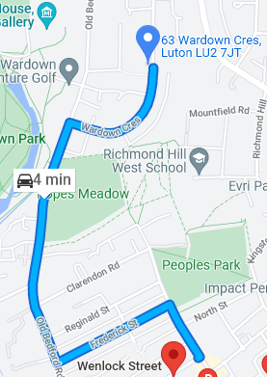
Noise Concerns: |  | N/A
Location Notes:

The house owner said there may be a guest staying in on the days that we’re filming (on Airbnb currently it says a guest has been booked for the 12th), he said we can film even with the guests still but to avoid the guest’s bedroom

Please attach a picture of the location:

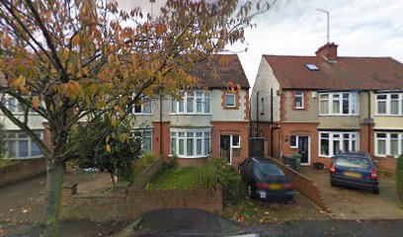

Please attach directions to get to your location:

