Call Sheet

Production title: 24k Magic
Director: Calvin Jones
Producer: Jaxmine Onyango
Production office address: New Bedford Rd., Luton LU2 7BF

Shooting date: Thursday (30/09/2021)
Crew call: 9:00am | Cast call: 9:30am
Estimate wrap time: 5:00pm
Location address: Barnfield College, Luton Beds LU2 7FB

Scene | Script | D/N | I/E | Scene synopsis | Cast needed
2 & 3  4  5 | N/A | Day  Day  Day | Interior  Exterior  Exterior | TV Studio  Car park  Church | Actors and Crew  Actors and Crew  Actors and Crew
Crowds/extras required: N/A
Technical requirements: Camera and tripod

Prop requirements: Carrot costume

Schedule:
Time | Activity | Details
9:00pm-9:50pm | Filming the TV Studio scenes | Will rain for the rest of the day
10:00pm-2:50pm | Reshooting any scenes we need to
3:10pm-4:50pm | Filming the St Mary scene

Useful numbers:
College - 01582 569569
St Mary - 01582 721867

Directions/parking:
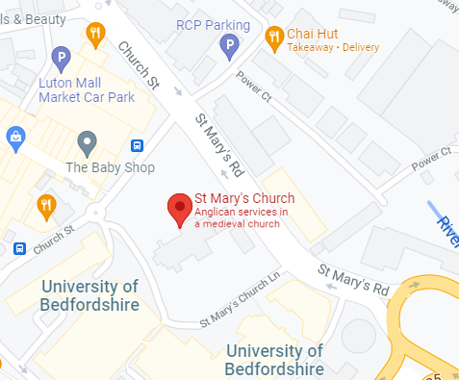
We will walk

