Call Sheet

Production title: 24k Magic
Director: Calvin Jones
Producer: Jaxmine Onyango
Production office address: New Bedford Rd., Luton LU2 7BF

Shooting date: Wednesday (29/09/2021)
Crew call: 12:00am | Cast call: 12:30am
Estimate wrap time: 3:50pm
Location address: Barnfield College, Luton Beds LU2 7FB
Riddy Lane Stores, 1B Riddy Ln, Luton LU3 2AD

Scene | Script | D/N | I/E | Scene synopsis | Cast needed
1& 2  3  4 | N/A | Day  Day  Day | Interior  Interior  Exterior | Inside the college classroom and the corridors  Inside the store  In the park | Actors and Crew  Actors and Crew  Actors and Crew
Crowds/extras required: N/A
Technical requirements: Camera, tripod and boom stick

Prop requirements: Carrot costume and “liquor” (glass of water)

Schedule:
Time | Activity | Details
12:30pm-1:20pm | Filming the classroom and corridor scenes | Will be sunny for the rest of the day
1:30pm-1:50pm | Filming the Ridley Lane Shop scenes
2:00pm-3:50pm | Filming the park scenes

Useful numbers:
College - 01582 569569
Shop - 01582 593871

Directions/parking:
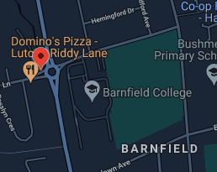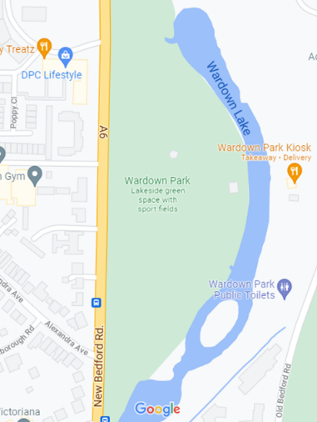
We will walk

