Brochure
I was already very confident in the images I’ll be using for my brochure as I really liked how my mock up turned out. Since I want to go with the black and red theme, I chose to use images with those colours
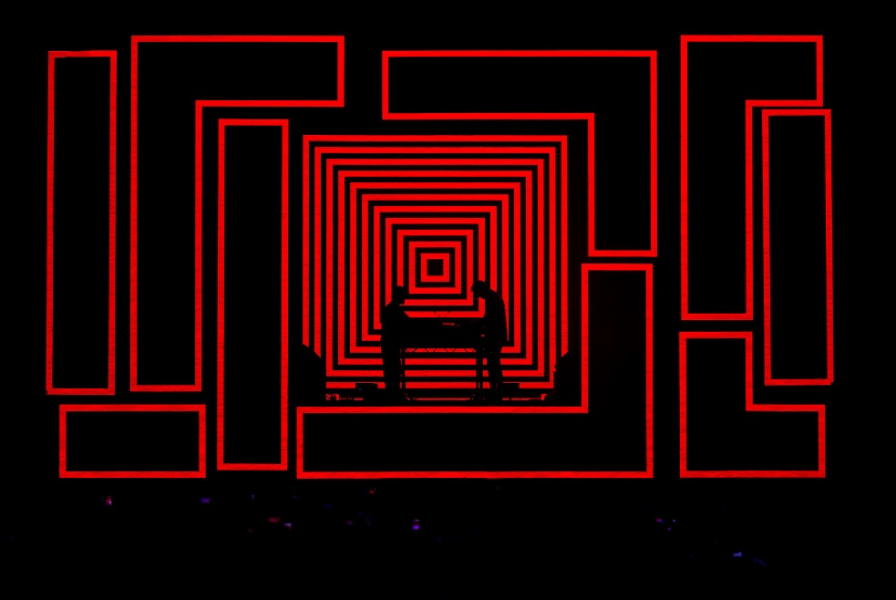
Bicep
I chose to use this image as I love how bold it is, it’s a photograph but it looks almost drawn with how bright the colours are. I plan to crop out the audience as you can see them down below and they distract from the image a bit. I also used a similar image in my mock up, but I prefer this one as the colours look more clearer to me here.
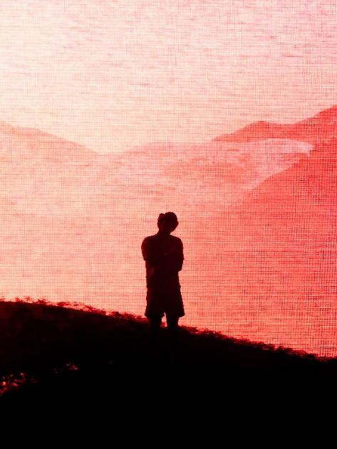
Tyler, The Creator
I feel like this image goes well with the one of Bicep so I plan on using it too, in general it looks very visually striking. I’ll edit it so that the red pops out more in the picture as to the left it fades into a peachier colour which isn’t what I want.
Magazine Double Page Spread
I originally thought I was set on one image I wanted to use for my double pages, but after thinking about it I think it might be better if the images used had more colour to them. I’d also want to feature another artist for my magazine spread as I know I’m already using an image of Tyler, The Creator for my brochure. I wanted pictures of artists who were headlining the festival like 50 Cent, Megan Thee Stallion and Lewis Capaldi. I’m not as set on the layout for the double page spread so I chose portrait and landscape images for me to work with

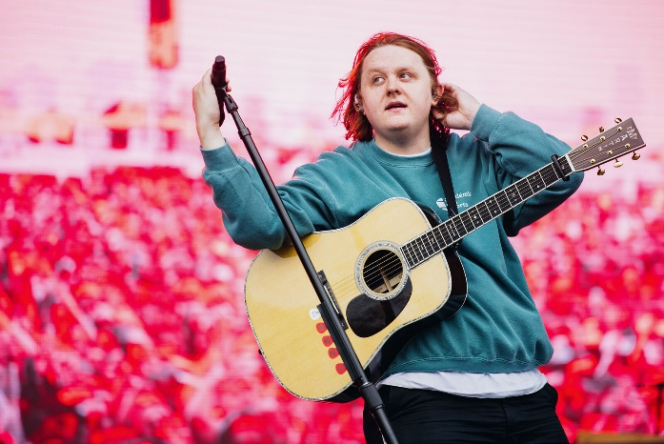
Lewis Capaldi
I personally think this is the best picture of Lewis Capaldi in the gallery. I like how the microphone stand is leaning and how the shot is framed, it leaves a lot of space on the right that I could fill with text. However if I do use this image, I’ll likely change the audience to be a different colour as I already have red for the brochure.
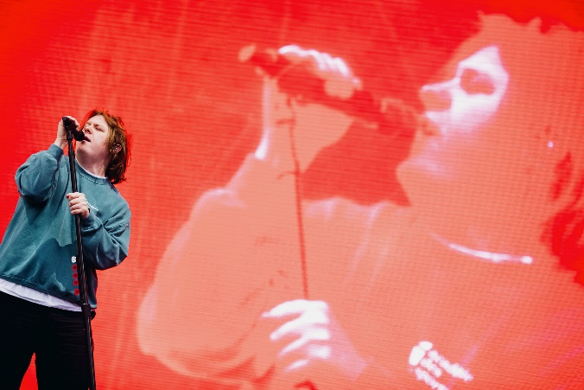
Lewis Capaldi
The main thing I like about this picture is how it shows Lewis on the screen, it acts as a really nice background. This also has the same problem as the previous picture though I imagine editing the colour would be easier on this image.
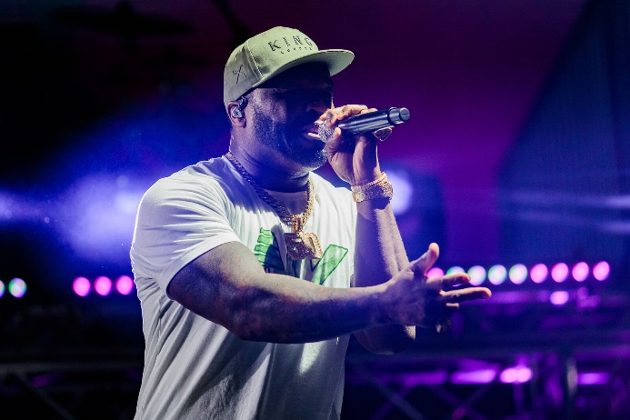
50 Cent
Many of the pictures of 50 Cent are pictures of the stage and crowd, so it was difficult finding an image I liked that only featured him. I really like the colours and lighting in this image and I feel like the lighting especially makes it stand out a lot.
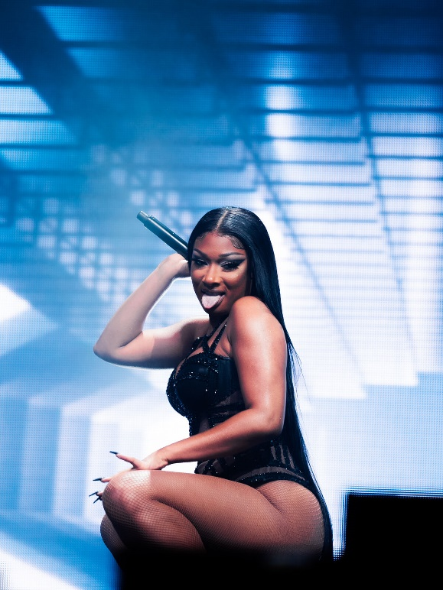
Megan Thee Stallion
I like the background for this image a lot and how it fades from dark blue to white, it’s visually appealing. Since I’m using red and black for my brochure, blue and white would act as a nice contrast to it.
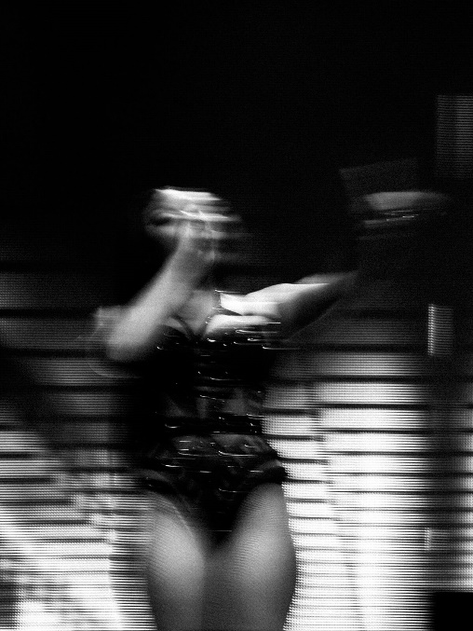
Megan Thee Stallion
Alternatively I could use a black and white colour palette with this image. I like the blur effect on it a lot, I feel like it’s an image festivals and clubs might use for promotional material due to that effect. There’s also an alternative image with the same effect but regular colours on the gallery site too.
Posters
After doing the moodboard, I noticed that a lot of posters didn’t actually have any pictures on it and instead had graphics and illustrations. I decided I wanted to do the same as I felt it’d give me more room to design and experiment with graphics and typography.

