I didn’t have a strong opinion on this unit starting out. The main reason for this was because I wasn’t sure what I wanted to do later in the unit other than something print-related again. It took me a bit for thinking about a debate topic I was interested in that included print, but I eventually went with “Is There a Need for Print-based Journalism in A Modern Society?”. This was later changed into “Is There a Need for Print-based Media in A Modern Society?” to be more general and so I’d have more topics to discuss (books for example). If I had to be critical on this part of the unit, I’d say I think I focused on journalism and newspapers a lot more than I needed to as there are other forms of print media.
The beginning of the unit went well, since the debate topic I chose was so popular I was able to get a lot of responses and research from it. I interviewed two journalists on the differences between writing for print and digital, did a poll asking people if they still read newspapers/magazines and did a questionnaire to figure out how society views print media. Overall, the responses were interesting to read.
I was originally planning to include the debate topic in my final product, the idea of a magazine having a “Are we dying?” or “Is print dying?” headline would be striking. When I was told the final product was supposed to prepare me for the next unit though, the idea of my debate topic fit less and less so I eventually scrapped it. When I decided I’d have posters included in my final product I wanted to base my project on a rave or music festival since a lot of my favourite designs were advertising those. I liked how bold the colours are and how creative you can get with them, so I wanted to create something similar.
I was planning on doing a poster, a double page spread and a brochure. I later added another poster and five bracelet designs after I got feedback that my original portfolio didn’t have enough in them. The main goal when choosing to do a portfolio of work was to improve my layout skills since I thought that was one of the poorer parts of my magazine for FMP. This was mainly because I immediately rushed into designing it instead of taking time with my mock up.
The first thing I wanted to research was what festival I should base my portfolio on. I did research into the most popular ones as no local festival interested me and eventually settled between Parklife or Field Day since I liked their promotional designs the most already. I was hesitant to pick Parklife over Field Day as their current years line up wasn’t out yet, but I was told that I didn’t need to base it off this year and I liked Parklife 2022’s line up enough to choose it. I knew that the festivals design wouldn’t matter too much since most festival with a theme usually change theirs yearly and I had to design my own, but I felt like my designs should mostly match what the festival is already known for (for example it would be strange if I was doing Glastonbury Festival and chose to do a completely different style from what they’re already known for).
When I chose Parklife as the festival I’d be basing my portfolio around, I decided to do more research into it. I looked at the full line up of artists, VIP, hotels nearby, prices for tickets, what time the festival opens and closes, options for travel and other attractions. The research I did into Parklife specifically was obviously the most important research as without it I wouldn’t know anything about the festival I was basing my entire portfolio on. I also had to write for my brochure and magazine spread and I referred to the research I did on Parklife constantly for those.
I also looked at tips for designing posters and brochures. Since I’ve never made either before, I wanted to make sure I knew some things I had to include in them. When I was making the final versions of my posters I nearly forgot to add the ‘call to action’ (Parklife website link) in my posters and only remembered because of the research I did. Without doing research into designing a trifold brochure, I wouldn’t have known how to format it properly (what side is front and back, how each page will look when I print it out).
I knew I could’ve used Adobe InDesign to design my brochure, but I wanted to use Illustrator as I’ve never used it before and this unit was an opportunity to try new things. I only used one guide for it and it was specifically about making a tri-fold brochure which was what I was doing, but in the long run I hadn’t really learnt all too much about Illustrator from that video. It was still useful though as it taught me how to set up a brochure layout to use in Illustrator and that’s all I really wanted from it. I feel like I could’ve done more research into Illustrator though, I was originally going to watch a more generalised tutorial on it but didn’t end up doing it.
The bracelets were the main thing that worried me at the time though as I wasn’t sure how I’d even make them (what size, is there a template for them, how would I even print those out?). I found a guide that covered all of them on Spoonflower. It was clear that it was written to get you to pay for their services specifically, but I didn’t have many options. The template that I used for my bracelets was from the site. I was originally going to get them printed from the site as early as I could but didn’t do it because it was overseas and I wasn’t sure how long it’d take for them to arrive.
Technically the least useful topic I did research on was how to print everything else (posters and brochure). I knew I was going to go with the same printers I contacted for my FMP so I did research into how I wanted everything printed instead. When I was done with production and I emailed the printers though, I was told that they couldn’t do that and that it’d have to be printed differently. The main takeaway from this is that I should’ve contacted them beforehand like I did with my FMP, especially since they’re happy to do recommendations. For my next unit I’ll definitely be doing that just to make sure I have everything right.
During pre-production I felt like I had managed my time well. During week 5 I gave myself time to find and contact different designers who could hopefully give me advice during production. I was working on designing my bracelets first thing so that I could hopefully get them printed and sent to me in time before the unit’s deadline.
I made a moodboard of other designs from other professional designers, majority of them were for something similar to what I was doing for my portfolio (advertising a music event). Having a moodboard helped me a lot while I was making my designs, especially with my posters. I also liked making it the most as I like looking at graphic design in general.
My original colour scheme was going to have a variety of different colour palettes for each medium in my portfolio, but I was given feedback that it’d be much better for them all to have the same colour palette so its clear that they’re advertising the same event. I’m glad I ultimately stuck to one colour palette by the end of production because it made everything look more professional. I chose the black and red from the picture on the front of my brochure and thought that having a slightly off-white colour would be more appealing than the usual default white.
Doing my mock ups helped me a lot with what I wanted for my magazine spread and brochure. I ended up keeping the left page of one of the magazine mock ups I did as I liked it the most and the people who I showed the mock ups to felt the same.

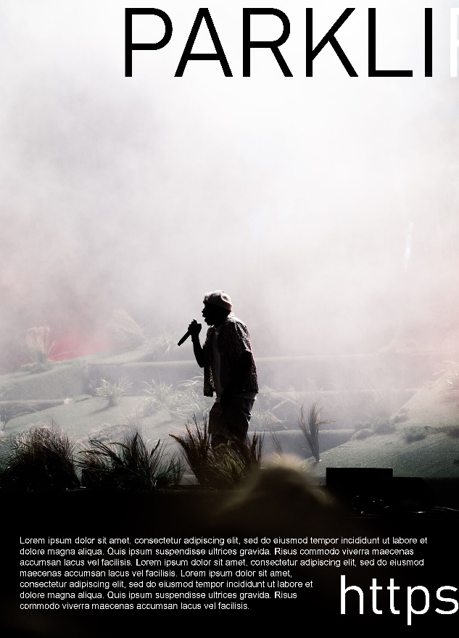 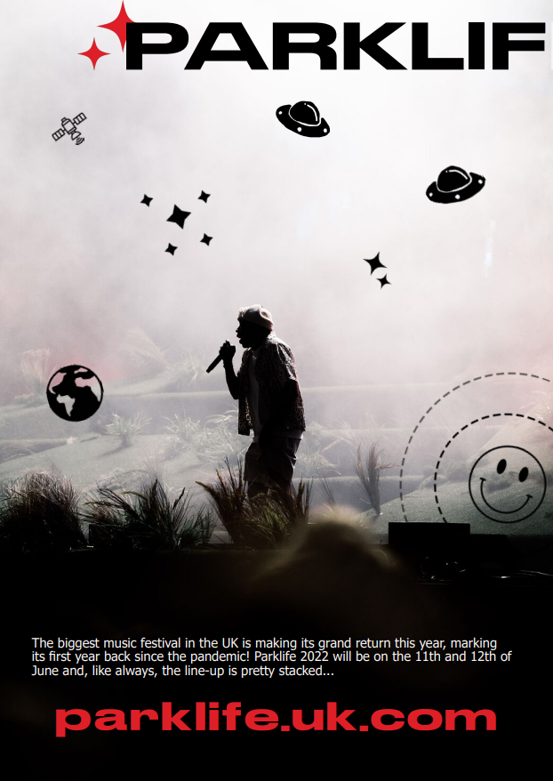
Magazine Mock-up | Final Magazine Design
The mock up of my brochure is a lot different than what I later did with it, but I was able to find images that I really liked and used in the final product. For the right section of the front I ended up using that idea for one of my posters instead. Doing my mock ups helped me with my layout design skills, I likely would’ve gotten stuck with designing my brochure if it wasn’t for this.
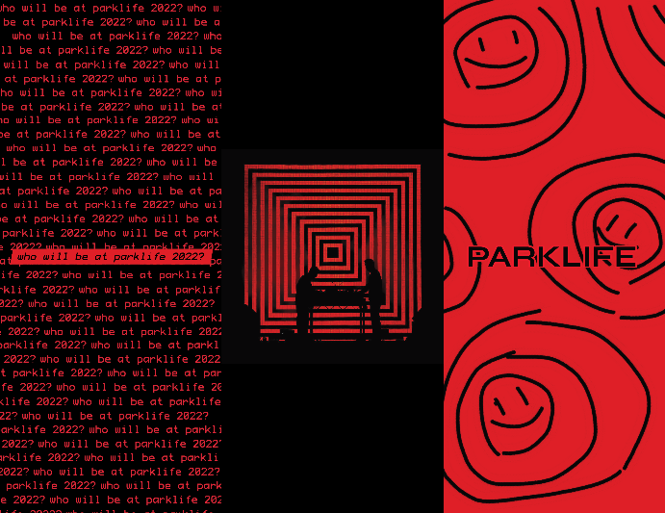 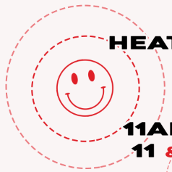
Brochure Mock-up | Final 2nd Poster
When making my mock ups I looked at other designs on Behance to help me with inspiration and how I should layout my magazine spread and posters, but I feel like I should’ve done more research into layout design since that was the main focus of this unit for me. Other than that I didn’t need to do research into anything else after my pre-production page.
I feel like production week (half term) was the worst week in this unit, I didn’t get nearly as much done as I should have. That was the week I was going to design my magazine and posters, but I had no ideas for them. I came in on Tuesday to start on my posters but ultimately ended up going home early with nothing because I didn’t plan for them properly.
I had an idea of what I wanted one poster to look like, but I wasn’t able to replicate it perfectly and felt a bit frustrated on it so I moved onto designing the second poster. While I was here I tried copying elements of the images on my moodboard and adding them to my poster, but I didn’t like how any of them turned out. I feel like a reason I struggled so much on my posters is because I didn’t create any mock ups for them so I didn’t even know what I wanted them to look like.
On Wednesday I stayed at home to draw some designs for my posters and magazine spread since I didn’t have many ideas. I should’ve done this earlier before production week like during the weekend leading up to it, or when I was making mock ups for everything else. Doing this really helped me get more ideas and I ended up using one of the designs I quickly drew (top left). The top one in the middle was my original idea for the first poster, but after drawing it I didn’t like it as much anymore.
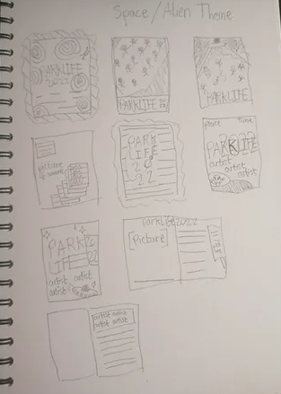
I didn’t like any of the mock ups I made for the magazine spread but I tried doing them in InDesign anyway and hated how they looked. I got feedback from the designers I contacted and they both said it was fine, but I disliked them so much I didn’t want to use them. Later on Adobe released a 2023 update to InDesign and since my project file was made in the updated version, I couldn’t use the file on InDesign 2022 (which majority of the computers at college had and I can’t update them due to lack of admin privileges). This meant I had to make a new file and start all over again, which I wasn’t too annoyed over.
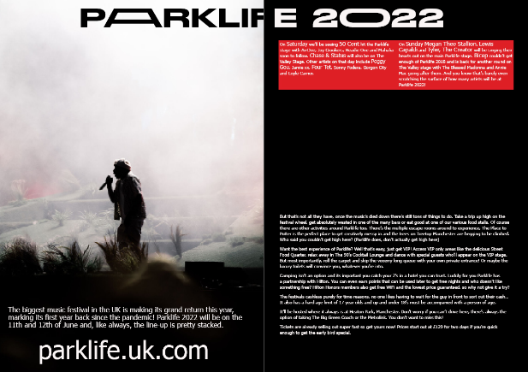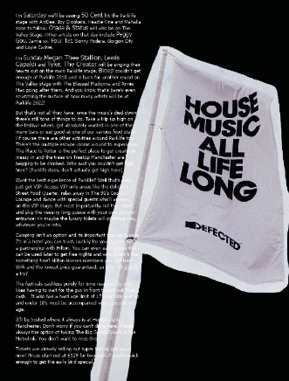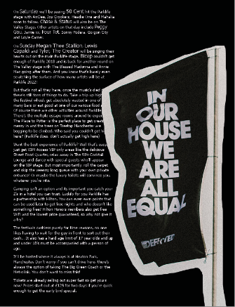
The main issue with the magazine spread was that I didn’t know what to replace the right page with. I like the idea I went with for the final product, but I think it was a bit of a cop-out. I’d already done a page layout similar to it in my FMP magazine before.
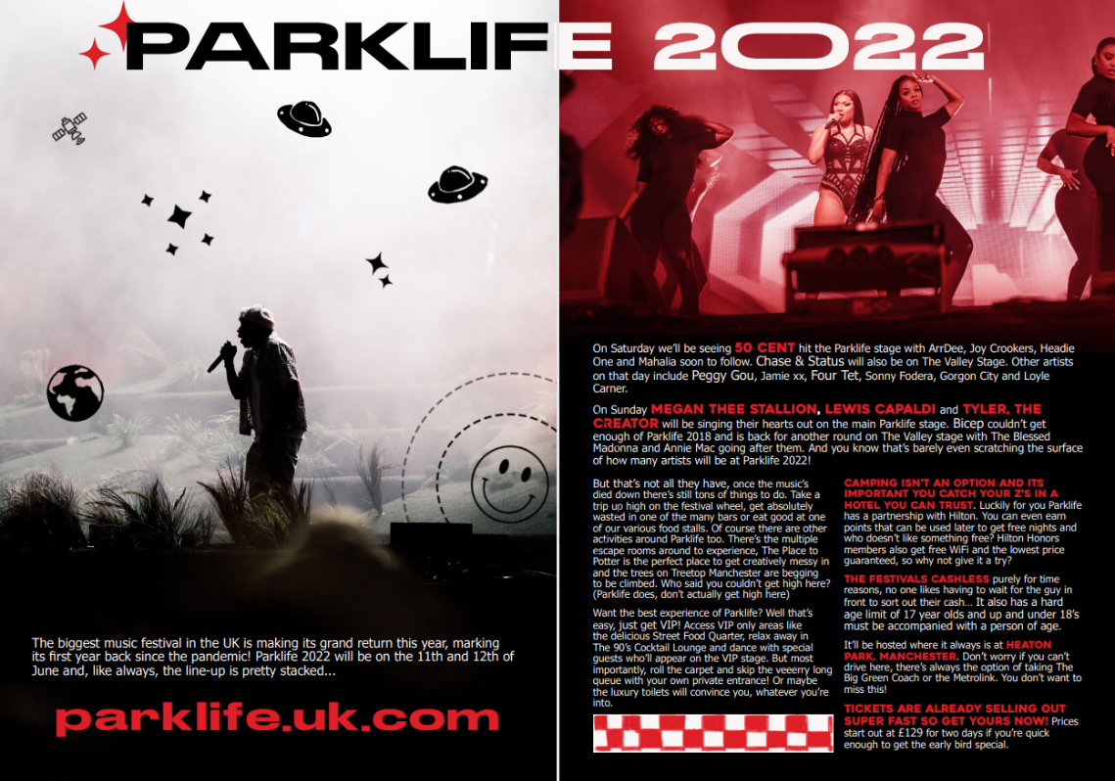 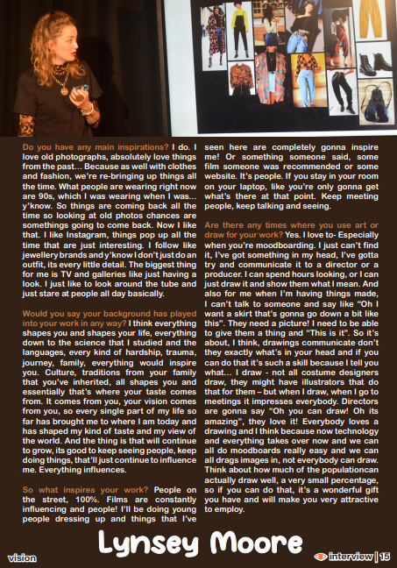
Parklife 2022 Magazine Spread | FMP Vision Magazine
This unit was meant to help me with my layout skills, especially with my magazine since that’s likely what I’ll be making for my next FMP, but I feel like I haven’t improved all that much. I can’t blame anyone but myself for not doing more research into layout design, for the next unit I’ll definitely have to dedicate some time to doing so.
The first finished design I want to look at are my bracelet designs.
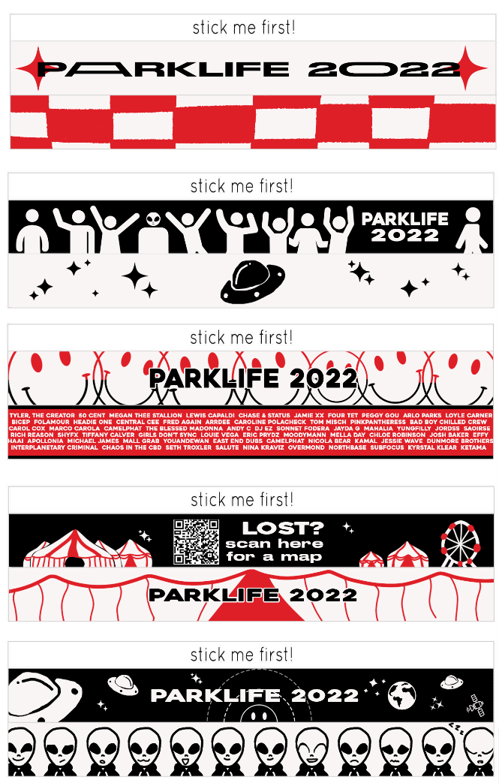
Adding them into the portfolio was a bit of a last minute decision so I wasn’t sure how I’d design them at first, but I think they look pretty good. I like all of the front designs but I feel like some of the back designs could be better, especially the fourth design. I like the idea of the back side of it but I feel like it could use some work, visually it doesn’t really go together with the front’s black background.
The first design wasn’t made with anything in mind, when I was starting I didn’t have any ideas so I made it all up as I went along. It feels the most likely to be seen on a professional product like this, but it also makes it less uniquely appealing. I think it’s nice and one of the designers that helped me through production agrees, but it’s not anything ground-breaking.

The third design originally had ‘Parklife 2022’ repeated in the back since I didn’t know what to put there, but Maria suggested putting the line up there instead and I think the third design looks a lot better because of it.
When I originally made the bracelets the last design wasn’t good, I ran out of ideas so I just put something random. I still didn’t have any ideas for the last bracelet design when I was making it, but I feel like its not too obvious and that it works still.
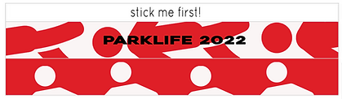
Original 5th Bracelet Design
Something that was extremely important for the rest of the portfolio was the comment Maria made about the significance of UFO/alien imagery. I decided instead of having it continue to not make any sense, I wanted to base the rest of the portfolio on that theme. This decision was the best one I made about the portfolio as it made them all having a unionising theme other than colour palette and font.
One criticism I got about the portfolio was that it felt like the magazine and brochure had a different theme from the posters and bracelets and I somewhat agree. I added the vectors to the left side of the magazine spread so it’d look more in line with everything else but for the brochure I completely forgot to by the end. I was going to add the same to the image at the right section on the back of the brochure but I didn’t like how it looked.
I like how my portfolio turned out. I was able to get everything printed (even if it didn’t come out exactly like I was expecting) and I like the designs. My favourite design was the first poster that I designed on a complete whim, if it wasn’t for the space theme I wouldn’t have been able to make something I liked (this goes for the bracelet designs too). Because my designs all had the same theme I was able to make things based around it rather than struggle to think of something that made sense for each medium. This was something that was mentioned when I was showing my final designs to someone as well, it adds as a huge strength to the portfolio.
I think another strength to the portfolio was the colour palette I chose for it. It’s bold and really stands out, especially in the brochure.
As I said before, I mainly saw this unit as a way to build up my layout skills and I’m unsure if I’ve really achieved that. I did learn a lot in this unit though as I’ve never made a brochure, poster or designed a bracelet before and through research I was able to make one that looks good and works as their respective mediums. I purposely used Illustrator to learn how that software works even if I don’t know if I’ll ever use it for my FMP.
My main issue with the design comes up in the magazine and its only a small error, but its still evident even in print. I forgot to crop this image so it comes up on the right page, making the text look like there’s a weird black curve over it.

I’m also unsure if I like the checkerboard I did for the bottom of the magazine. I did it because I remember Maria saying that the hand-drawn checker pattern only appeared once in the entire portfolio, but I feel like in the magazine it looks a little out of place. I think it’d have been better to go use the vectors in that space instead.
I also got feedback on one of the poster and bracelet designs.
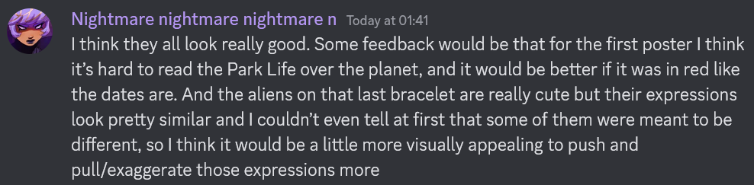
I personally liked how the Parklife text looked with black a lot, but that doesn’t matter if someone can’t see it. I think in hindsight it would’ve been better if I made it a different colour (maybe the off-white colour) instead so it stood out in the poster more.
The back of the last bracelet design was a bit rushed due to the lack of time I had on them. I do think the expressions could’ve been more exaggerated though I don’t think it’s too much of an issue as that side of the design wouldn’t have been very visible regardless.
It was difficult getting audience feedback for this unit, but the two cited above are from people who would be in the primary and secondary target audience (20-25 & 17-19 year olds). I still feel like the target audience of my portfolio would like it though due to its boldness and overall fun designs.
Compared to Parklife’s own posters, mine isn’t as illustrative as theirs purely because of time constraints and lack of confidence in my own art. But I still tried to use a similar style Parklife does, for example these posters I found while doing research into Parklife mainly features one neon colour and pure black. I used a similar restrictive colour palette for my portfolio. The one in the middle looks slightly similar to the way I designed one of my posters with the position of Parklife being in the middle. They also use very bold fonts for their posters which I did throughout my poster and entire portfolio as well.
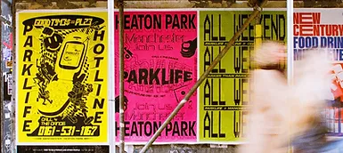
For an example of a magazine, Muzine was made by multiple professional designers and was one of my inspirations while making my mock ups. This double page spread also uses vectors and icons with a real life picture of an artist, like with my magazine spread. The right side also has a similar layout with highlighted text being in a bigger font from the rest of the paragraphs.
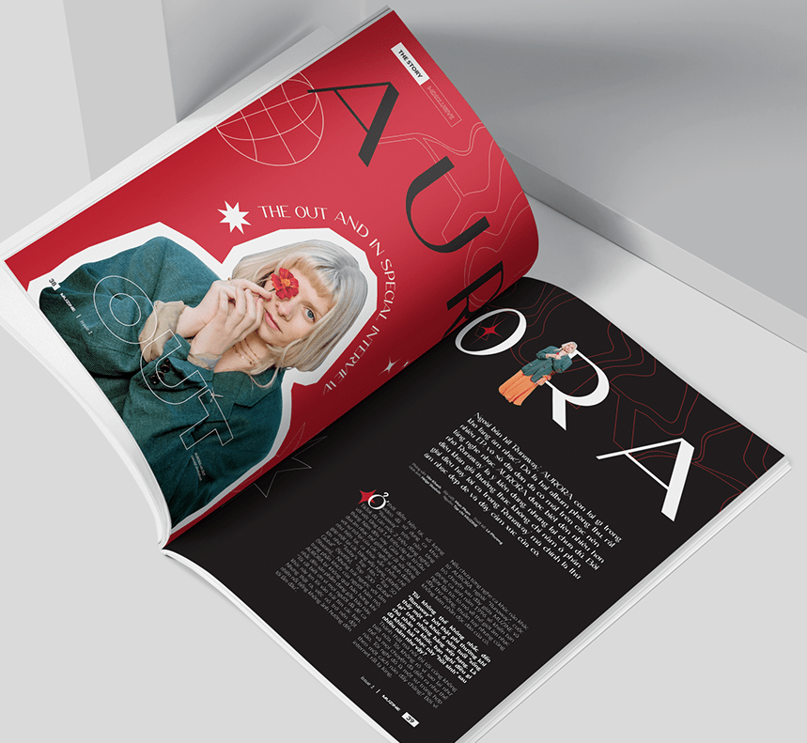 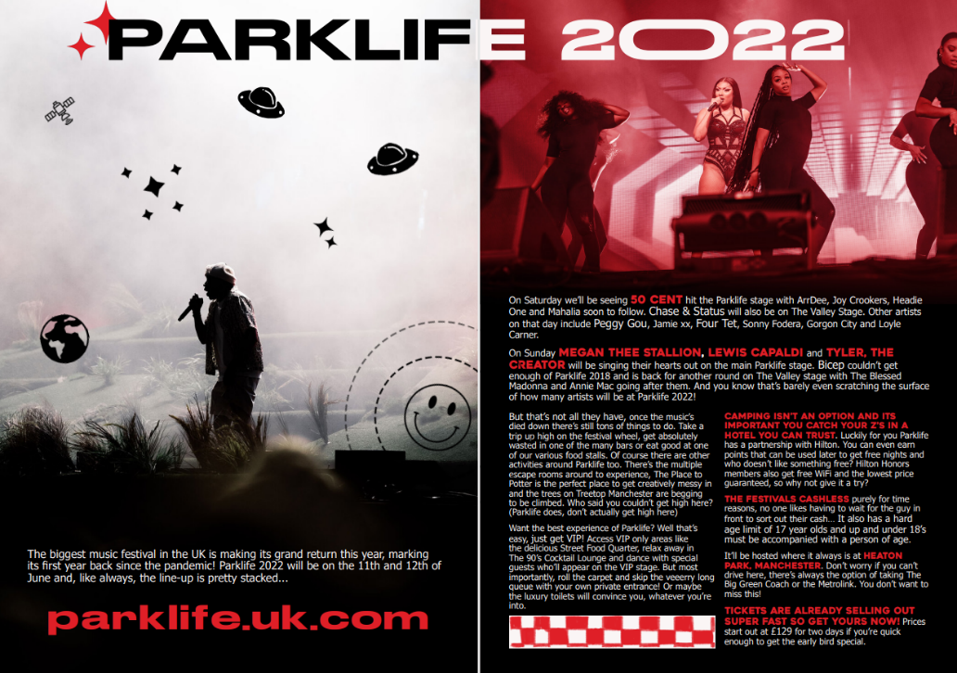
Muzine Music Magazine | My Magazine Spread

