Headings
For the headings I wanted them to be bold and match the Parklife logo. I plan on using the same fonts for everything in my portfolio so I want to make sure to choose something I’m happy with.

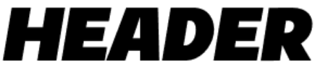
[Dafont] Danbury Caps
I feel like this font fits with what I want well, its slanted slightly but its bold and in all capitals like the Parklife logo is. I also think the slanted look makes it stand out more compared to the logo.

[Dafont] Heavitas
This font does the same, even if I feel like it’s a bit basic.

[Dafont] Akira Expanded
This font feels more unique compared to Heavitas as its wider than most usual fonts. I’m not sure if I’ll use it because I don’t feel like it fits with Parklife’s design much but I do think it could still work.
[Dafont] Provicali
This is a better version of Heavitas, I like how the kerning on this font makes the letters closer together. It also feels more pronounced and bolder compared to the other font.
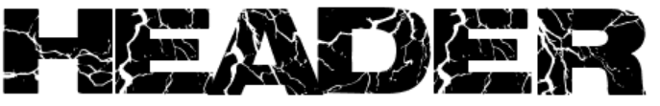
[Dafont] Electrical
I like how this font stands out with the lightning theme on it. I’m unsure if I’ll use it because it might not fit with my images that well, but I still like it and may use it for my bracelets.
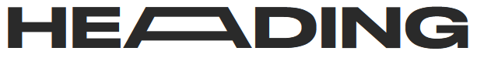
[Befont] Stretch Sans
I like the stretch function of the font and feel like it could work really well with my designs, it feels like a font Parklife would use even if it doesn’t match its font logo.
Subheadings
I’m not completely sure what I want my subheadings to look like, so I wanted to keep my options open and pick different font styles.

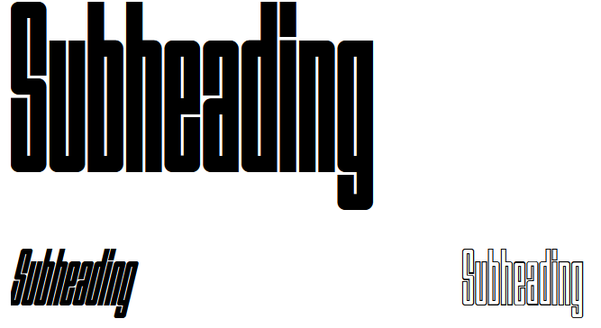
[Velvetyne] Outward
I like how this font has an italic and outline version as I’m unsure what exactly I want from my subheadings yet. I think this font stands out against my heading options, my only worry with it is that I feel like it might be a bit hard to read and might not fit as a subheading.
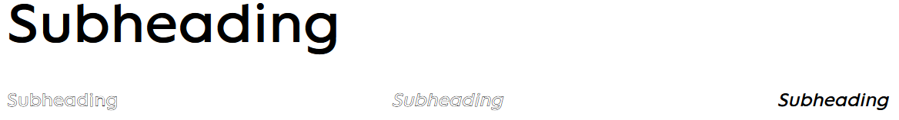
[Velvetyne] Lack
I like this font for similar reasons as I like Outward except that I feel this font works much better as a subheading. Its also easily readable and looks like it’d match with the heading options I have well enough.
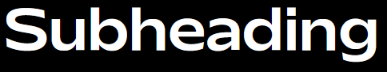
[Collletttivo] Mattone
I likely won’t use this font over Lack due to how bold it is, but I still like it and might use it for my brochure or bracelets.
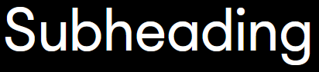
[Collletttivo] Porpora
This font feels basic enough to be my subheading while also not looking too bland. I don’t know if I’ll use it for my subheading though as I’m unsure if it’ll go together with my font choices for headers.
Text
I want the text font to be basic default fonts so they’re readable. I remember one criticism I got for my magazine I did at FMP being that I shouldn’t use a bold font for the text, so I’ll keep that in mind.

text, parklife 2022, words
[Default] Tahoma
This font looks fine enough but my only concern is how bold the text is. I don’t think it’s bold enough to be too much of a problem but I want to try and find an alternative.
text, parklife 2022, words
[Default] Calibri
I’m unsure if I like this font as much as Tahoma but I do know that it’s common and readable as it’s the default for Microsoft Word.
text, parklife 2022, words
[Default] Arial
A very basic font, I like how it has many different alternatives to work with like Arial Nova and Arial Narrow.

