I didn’t have much strong feelings about the unit at first, I knew I wasn’t much of a fan of the game show but hoped that I’d be able to make a better show than the one made previously. I was the camera operator previously and thought I did okay, but I wasn’t too proud of the result of the show still. I ended up with two roles for this unit, one for pre-production and for the actual production. I was assigned to be the lighting producer and the vision mixer. These roles are all very different from each other so I didn’t end up having a specific improvement I wanted to do, rather I wanted to do all I could with my roles on making a show professional enough to be on TV.
I felt comfortable with my roles as I had previous experience with the vision mixer (I used it during the interviews with the music students last year). The only thing I knew about the vision mixer at the time though was how to cut from camera to camera so I was still slightly concerned about it, especially since I’m ultimately going to be the one in charge of what the viewers would be able to see in the show. I vaguely knew you could use graphics with the vision mixer as well but had no idea how to yet. Being the lighting manager was unfamiliar to me since I’ve never properly worked with the lights before, but I thought it’d be simple enough. I expected that I’d have to change the lighting plan multiple times as we kept having more rehearsals and I was right on that.
In class we were divided into three teams and had to come up with a concept for Live TV show, I was part of the news group. I didn’t want to do news as I personally had no interest in it, but I had no ideas so I went along with the group. Ultimately the concept the class voted on was the gaming-based magazine show. I voted for it since I thought it had the most potential, it had a clear target audience it was going for and sounded unique as from my research into magazine shows there wasn’t any with a primary target audience of 16-20 year olds. It was also a bonus that I’m interested in gaming, but I think that’s a testament to how much potential it had as I’m also part of the target audience.
I also had to learn a lot about Live TV for this unit too since I don’t watch TV let alone Live TV. If you asked me about Live TV prior to this unit I’d only be able to say that it was TV that was recorded live and that’s it. We first did a bit of research into what Live TV and As-Live TV were and at the time I had never heard of the term “As-Live” before. Then I analysed each type of live show as well (chat shows, news shows & magazine shows), comparing two of each. I’d say this helped with learning the codes & conventions of all of the mediums as I came out of it now having a thorough understanding of what should be in them, like how magazine shows tend to be more relaxed and comforting than a news show and them often using animated title graphics.
I did research on TV Guides and later on did more BARB research so I’d know the most popular days & times that people watched TV. Doing this research helped me with settling on a time and day for the show to be aired on, from the BARB research specifically I also found out the most popular shows on E4. Knowing this mainly helped in production meeting 4 (time slots & day), I said it’d be a bad idea if we aired at the same time as Hollyoaks (7pm) as that’s the most popular show on E4 and they wouldn’t be willing to give up its time slot.
I think the most significant research I did was the questionnaire, I and the rest of the class got a lot of our ideas from the questionnaire responses alone. For me personally I got the idea of the colour scheme being black and neon colours from a response in the questionnaire. There were some questions I asked that already had answers to them though, like the channel the show airing on being E4 and us already knowing there’d be more than one host in the show. There was also the research I did by reading the manual for the vision mixer which ended up helping a lot with setting up the graphics on the ATEM software. Looking back on it, I should’ve researched the graphics more as I actually didn’t know the button to make the graphics appear on the vision mixer itself was until I guessed it correctly (which didn’t take long, but the issue was that I didn’t know).
The least effective research done was on the competitors, the only E4 magazine show I could find that was directed at the primary target audience was a show that wasn’t even on E4 anymore. Looking at channels that were competitors of E4 didn’t really help me with anything either. The research on this section could’ve been better too as I only talked about shows that already ended for competitors with the same primary audience.
Pre-production wasn’t too difficult as I only had to do research into true or false leaks for the script and lighting plans. While dressing the set I experimented with the light stands and the positions of them, this is evident with the multiple videos of them. Doing the research for the leaks were fun but now that I think about it, I don’t think they were ever used in the show anyway.
When it came to doing rehearsals, I think I did fine as my roles. As the lighting manager I had a lighting technician that I had to direct, I didn’t have to very often though. I already knew where I wanted everything so it was easy enough to give him instructions on what to do, like where to move a lighting stand or to change settings on one of them. He also helped me with where to place each gel since I at first completely forgot I had to add them. As this was my pre-production role I didn’t have to do much for it, only occasionally going on set to change the lights how I see fit. Another thing I kept forgetting about while doing lighting plans was that the TV needed to be visible for the presenters to read the script, this wasn’t really an issue since with how I positioned the lighting stands it only needed to be moved over slightly anyway.
With the vision mixer, it was very simple before the ATEM software worked. I already knew how to cut to different cameras and I wasn’t planning on using the transitions at all since those wouldn’t be seen in a professional TV show to begin with. All I really had to do was listen to the director on what camera to cut to and that was it. When the graphics finally did work it was very simple to use on the ATEM software, because I skimmed over the manual previously I was able to remember what to do to make the graphics appear as media players on the system. However, as I mentioned before I realized I didn’t know what button I could use to make them appear. I was shown that I could hold a media player button & shift at the same time to show it, but that made the background behind it black and completely cover the screen so that wasn’t an option. I quickly found the DSK 1 CUT/AUTO button was the one I needed to press, but that was just out of complete luck on my part.
At first I found my role almost boring since all I was doing was pressing buttons according to the director, but I realised I could be doing more. As we continued having more rehearsals, I mainly focused on listening to the director when cutting to cameras but I felt more confident to tell him when a shot was too out of focus for me to cut to or to cut the cameras on my own whenever he was giving busy giving directions to the camera operator. There were still times when I messed up with cutting cameras since I was looking at the screens rather than the buttons themselves, but those were very few and far between.
Compared to the everyone else in the class, I think I had the two easiest roles. Everyone on set had to move positions quickly, the cameras having to move to focus on a presenter during the end of the live gameplay section to the retro gaming interview was the hardest one in my opinion (especially since I had limited time to cut to the only camera that wouldn’t move). We all learned very quickly as we kept on doing more rehearsals, especially the camera operators and the presenters. The first few rehearsals are obviously very messy since they had to get used to the speed of everything and memorise when and where to move things. I think the presenters found the script the most challenging: they kept defaulting to reading it, had a lot of awkward pauses due to reading it too fast or the script not having enough content in it and during the first few rehearsals we had to cut because the script teleprompter stopped moving. Overall, I think we all did very well as a class.
I wouldn’t call my roles super enjoyable or anything, I can’t say I had many strong feelings about doing them other than the satisfaction of finally getting the lights perfectly how I wanted them in the dress rehearsal. For me the most fun part was the set dressing, I talked about it in my analysis of rehearsal 3 but I loved how vibrant the set is. I think the props (the consoles, gaming-related lights and even the plushies specifically) and colours really fit with the modern gaming aesthetic our primary target audience would like. There are also the gaming consoles on the other shelf which appeal to all audiences, the modern consoles would appeal to the primary and secondary audience while the tertiary audience would appreciate the retro consoles on there as well. I like how both shelves get shown off independently (the plushies are shown for the interviews and the gaming consoles are shown during the controversy talk) and it was more of a coincidence that this happened but I really liked the game over light with the Pikachu toy in the middle. The Pokémon ball and posters on set also helped fill in the dead spaces that would be there otherwise. If I had to say anything negative about the set though, looking at all the plushies and realising most of them are from Nintendo made me wonder if the time the show the would air (9pm) at was really a good idea, although there is the edited version that’d air on Saturday afternoon as well.
The live date had to be changed due to the lack of rehearsals we were able to have. During rehearsals we ran into a lot of problems, if I remember correctly we were supposed to have way more rehearsals than we were able to have. There was a problem with the ATEM software not working as it wasn’t connected with the vision mixer, this meant for a long while I couldn’t use the graphics for the show. This was later fixed before the dress rehearsal. The only graphics that were meant to be loaded onto the media player was the social media graphic and the (now scrapped) lower third graphic anyway, so during the time it didn’t work I just didn’t use them. There was a slight issue with the lighting during the first half of the rehearsals too, although that turned out to be the cameras being on the wrong ISO.
There was an issue with the comms cutting out every 25 seconds which meant the gallery and the set (specifically the director & producer and the floor manager) couldn’t hear each other. This was fixed, the problem happened again a few days later, was fixed again but instead of the comms cutting out there was now a static noise that played every few seconds. Since I’m the only one in the gallery without headphones I wasn’t sure if the problem was ever resolved, but during the time it wasn’t we kept on continuing with the rehearsals anyway.
Issues with setting up the graphic on the ATEM software were usually resolved quickly. There were times where the graphic appeared completely green or white, wouldn’t show up at all or would show up faded. I must admit that all of these instances were mostly just me. Below the knobs on the vision mixer are a bunch of smaller buttons, I had no idea what they did but they seemed to affect the bottom right of the screen so I was curious and messed with them so I’d be able to figure out what they did. I’m still not completely sure but I know one of them can be used as a mask, for example you could have a shot of something as the background and another camera shot of someone on the top corner to show their reaction. It could’ve possibly been used for the quiz, but I didn’t know how to do this consistently and didn’t want to risk anything.
Before rehearsals even began there was a problem, one of the first production meetings were about the roles we were being assigned and only one person was assigned to be the presenter. We were planning to have two presenters though so a casting call was held, but only one person came for it and they weren’t suited for the role. Something I mentioned in my questionnaire analysis was that it would go against codes & conventions of a magazine show if it only had one presenter, every single magazine show I’ve seen had two (Good Morning Britain, The One Show and Blue Peter).
The biggest issue easily though was the sound and throughout the rehearsals it just kept on getting worse. From what I know it was no fault of our own, apparently one of the equipment used for the sound was very old and tended to stop working. At first there wasn’t enough microphones to use for the entire show as we only had three but we needed some for the two hosts, the two people being interviewed for the show and for the person playing live gameplay. Then the microphones we did have kept not working, I’m not sure if it was because of the batteries or the microphone itself. The last problem was happening since rehearsal 4 which we didn’t notice until we watched it back, the sound for the entire show wasn’t being recorded. We thought we fixed this issue in time for the live show, but when we were finally finished with the live show and tried to watch the live we realized the sound hadn’t been recorded at all. It wasn’t recorded for the dress rehearsal either. This was obviously a very big deal as it meant we wouldn’t be able to get audience feedback (which was the entire point of this unit) from the actual live episode. We decided that it’d be best to get feedback from one of the previous rehearsals instead so we’d at least have some feedback.
I think when it came to the final day itself though, everyone did very well. The presenters had more genuine moments that were funny due to the script changes before the dress rehearsal and the cameras moved faster from set to set. The presenters faced the camera more and said their lines more naturally as well. In the gallery I was given clear instructions by the director on what to cut to and told him whenever a shot was too out of focus for me to cut to. Compared to the rehearsals where there was a major issue of the presenters reading off the script and therefore not facing the camera, I think there was a clear improvement between them and the live show.
We couldn’t do a rehearsal with the guests for the interviews due to them being unavailable during that time, but we were able to rehearse the quiz round. If I had to say what was the worst part about the show it’d easily be that round. There was a point where the wide shot camera suddenly moved to the right for no reason, during the Mario Kart round I couldn’t cut between cameras often due to other cameras being out of focus and during the previous rounds I sometimes cut to the wrong contestant.
That’s also the reason why I felt that this was one of my worst performances compared to all the other rehearsals. I feel like it might’ve been because we didn’t have many rehearsals with real people and there were a few times where I thought the wrong contestant was faster to answer due to the buzzers. We had to quickly find another buzzer since we didn’t have anything else and we found something that could act as a shaker, however the Pikachu toy was louder than the shaker which meant there were times where it was hard to tell who was actually the first one to buzz in. I think if we really had nothing else to use as buzzers we should’ve scrapped it and used phones instead, having the buzzer be a set noise that those can play when a button is pressed.
I was slow on the social media graphic at the introduction, although I don’t think this was too bad since I still made it show up while the presenters were still shouting out the show’s social medias. At the time I also thought the transition between the retro gaming interview and retro gaming video was awful but looking back it wasn’t too terrible. There are a few seconds of black before each pre-recorded item because that’s meant to give time for the video player to fade off the screen, but it also showed up a lot during the rehearsals as an awkward pause.
I think at the end though, I’m proud of how this show turned out. I think this was much more entertaining and fun to watch compared to the game show, even being very professional. The show was successful in interesting our primary target audience as seen in the questionnaire we put out for the show’s rehearsal. We were only able to get audience feedback from those twelve people unfortunately as we couldn’t show audiences the actual live show itself.
A majority of the audience who answered the questionnaire said they enjoyed the rehearsal and found it very entertaining and informative. In the proposal, the purpose of the show was to entertain the audience. The responses also said the show was upbeat and had very good pacing. None of the topics go on for very long and are quick, this would appeal to the primary target audience as they’re stereotyped with having short attention spans but would be able to follow the show well.
One of the biggest strengths of the show was the set design. The primary target audience considered the set design very creative and detailed, when asking them about their favourite part of the show the set design was the most popular. As said before, the set design was made to appeal to all three of our audiences and it clearly appealed to our primary target audience.
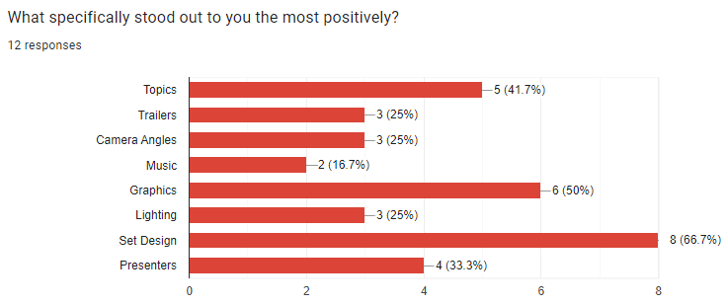
As seen above, the graphics were the second most popular part about the show. The graphics were made to appeal to the primary and secondary target audience, when choosing the theme of the show we wanted to go with a more modern gaming aesthetic. The colour scheme of the show (black & neon blues/purples) was inspired by the look of both popular gaming PC’s and the look that’s been the most popular recently is a black and RGB look, like the pictures shown below. However we were aware that this look goes against the tertiary audience and what they might consider game consoles to look like, the game consoles they had tended to use the colour grey the most.
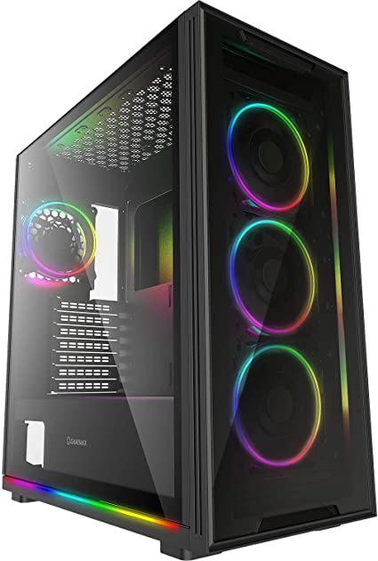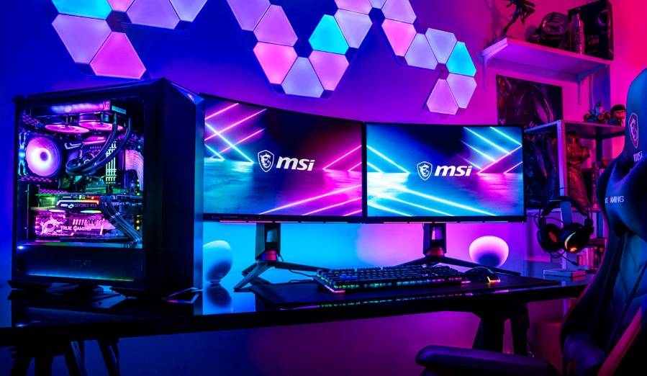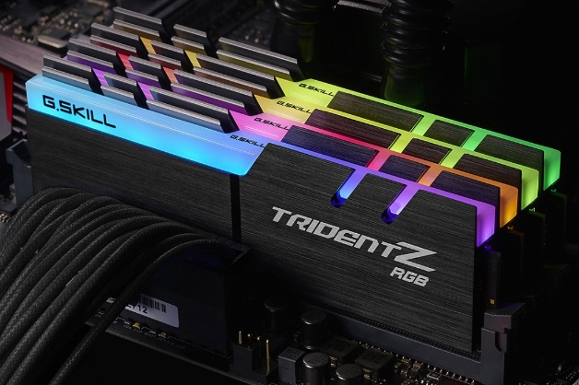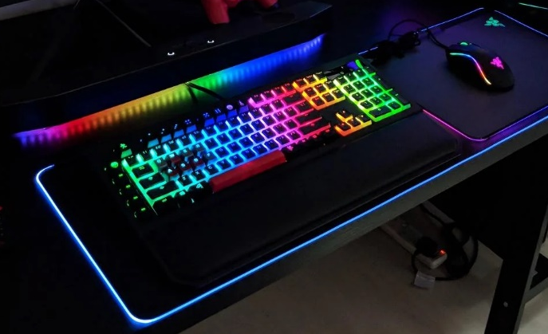
The topics were also well liked, we made the topics more diverse so it’d appeal to all of our audiences. For the primary and secondary audience the show features upcoming games & trailers and live gameplay. Both of those audiences would be interested in new games to play and the live gameplay features the very recent game Sonic Frontiers, so both audiences would tune into the episode to see gameplay of it. The audiences would also be interested in the questions the presenter asks to the person playing the game as the presenters ask about the controls, the story of the game and how enjoyable the game actually is. It also helps that one of the presenters and the person playing the game are both also Sonic fans, so they can give insight into how different the game is compared to other recent entries in the series.
The primary audience specifically would also be interested in the controversy talk in the show as it talks about recent controversies about gaming, including the end of it where the presenters read out a comment from social media. The comment came from the show’s Discord server, which could compel this target audience to join and follow the show’s social medias. When asked if the primary target audience would, most of them said they would. Incorporating social media into the show gives a chance for the show and the primary audience to interact more in ways like this as well.
The tertiary audience would be interested in the retro gaming section & interview as those are the consoles they grew up playing on. They also might be interested in what the newer generation have to say about them as well. In the pre-recorded video there’s more information on retro games that the tertiary audience might’ve not known about and at the end there’s a section of interviews about people’s favourite retro game. The tertiary audience would appreciate this as there’s a wide range of games talked about and they’d remember their time with their favourite game, it might’ve been one of the games mentioned in the video too.
The advertisements in the show were made to fit with everyone, but it does target the primary and secondary target more with ads for the new iPhone and Asos. There are also a few game related ads such as the ones for Pokémon and Sonic Frontiers, a few ads related to a stereotypical gamer are also in the show like the ad for GFuel. In the questionnaire the primary target audience all agreed the adverts were suitable for the audience.

